I/O Supervisor Guide for Windows 9x/Me Operating Systems

Table of Contents

Section 1 - Scope and Purpose 3
Section 2 - Introduction 3
Section 3 - Storage Technology Version History 4
Section 4 - IOS General Architecture 5
Section 5 - SCSI (NT 4) Miniport Driver Topics 8
A brief summary of the SCSI Miniport initialization sequence 8
Windows NT IOCTL unavailable with Windows 95. 8
Older Windows NT miniport drivers 9
Unraveling the Scatter Gather Descriptor (SGD) Confusion 9
BufferAccessScsiPortControlled Flag Information. 10
How to uniquely identify a specific SCSI adapter in a DCB 11
Dynamic device removal/installation (hot-swapping) 12
ScsiPortSetBusDataByOffset 12
On obtaining both an I/O range and a memory window from within a SCSI miniport: 12
Mapping between physical and linear (logical) memory 13
CDROM and DVD CDROM Issues 13
Recommended MaximumTransferLength 16
Developing a Multifunction INF file 16
The Extended IOP Structure 16
Additional Differences in SCSI between Windows 95 and Windows NT 4 17
Miscellaneous Questions and Answers 18
Additional SCSI Reference Material 22
Section 6 - IOS Port Driver Topics 23
IOS Port Driver general theory of operation 23
IOP Serialization 24
What are the rules for making a R0 read/write call from an IOS port driver? 26
Section 7 - Debugging tools 30
Debug binaries 30
IOS dot commands 30
Additional debugging techniques 31
Glossary 33
Appendices 35
Appendix 1 – Additional resource materials 35
Appendix 2 - IOS internal data structure detail 37
IDA (IOS Data Area) 38
DVT (Driver Vector Table) 39
DDB (Driver Data Block) 40
DCB (Device Control Block) 41
IOP (Input/Output Packet) 44
SRB (SCSI_REQUEST_BLOCK) 45
Appendix 3 - IOS Registration Flowchart 46
Appendix 4 - IOS Layer Drivers 53
Appendix 5 - IOS Sample Code 55
Supplemental Listings 57
Listing 1 – PCD (Platform Configuration Data) Structures 57
Listing 2 – LDM (Logical Device Map) Structures 59
Listing 3 – DVT_feature_code Definitions 60
Listing 4 - Sample .IDUMP report 61
Supplemental Tables 69
Table 1 - SRB Functions 69
Table 2 – IOS Inquiry Type Table 70

Document Amendment History

Revision Date | Section | Subject
000510.1 |  | Initial release
000816.1

The information contained in this document represents the current view of Microsoft Corporation on the issues discussed as of the date of publication. Because Microsoft must respond to changing market conditions, it should not be interpreted to be a commitment on the part of Microsoft, and Microsoft cannot guarantee the accuracy of any information presented. This document is for informational purposes only. MICROSOFT MAKES NO WARRANTIES, EXPRESS OR IMPLIED, IN THIS DOCUMENT.
Microsoft Corporation may have patents or pending patent applications, trademarks, copyrights, or other intellectual property rights covering subject matter in this document. The furnishing of this document does not give you any license to the patents, trademarks, copyrights, or other intellectual property rights except as expressly provided in any written license agreement from Microsoft Corporation.
Microsoft does not make any representation or warranty regarding specifications in this document or any product or item developed based on these specifications. Microsoft disclaims all express and implied warranties, including but not limited to the implied warranties or merchantability, fitness for a particular purpose and freedom from infringement. Without limiting the generality of the foregoing, Microsoft does not make any warranty of any kind that any item developed based on these specifications, or any portion of a specification, will not infringe any copyright, patent, trade secret or other intellectual property right of any person or entity in any country. It is your responsibility to seek licenses for such intellectual property rights where appropriate. Microsoft shall not be liable for any damages arising out of or in connection with the use of these specifications, including liability for lost profit, business interruption, or any other damages whatsoever. Some states do not allow the exclusion or limitation of liability or consequential or incidental damages; the above limitation may not apply to you.
Microsoft, Windows, and Windows NT are trademarks or registered trademarks of Microsoft Corporation in the United States and/or other countries. Other product and company names mentioned herein may be the trademarks of their respective owners.
© 2000 Microsoft Corporation. All rights reserved.

Section 1 - Scope and Purpose

This document applies to all versions of Windows 95 through Windows Me.

Manufacturers of storage devices can use the information in this document to facilitate the development of port and miniport drivers for Windows 95, Windows 98, and Windows Millennium Edition (Windows Me) operating systems.

More specifically, this document:

- Serves as a master integrating roadmap, addressing Input/Output Supervisor (IOS) technology
- Updates the reader with the latest information about IOS technology, tools and tips
- Embellishes the “Storage Technology Reference” section of the Windows 98 Device Driver Kit (DDK) available by MSDN subscription or as a free download at http://www.microsoft.com/ddk

See Appendix 1 – Additional resource materials, for companion resources.

Section 2 - Introduction

IOS is a key kernel component in Microsoft Windows, managing the following hardware technologies:

- IDE fixed and removable storage devices (disk drives, CDROM, DVD etc.)
- SCSI fixed and removable storage devices (disk drives, CDROM, DVD etc.)
- Legacy 1.44MB floppy disk technology
- Storage devices using other hardware interfaces such as a parallel port
- SCSI Pass through (tape drives, printers and other devices connected to SCSI bus)
- USB Storage devices

IOS does NOT address remote storage devices (devices accessed through the network using VREDIR.VXD, VSERVER.VXD, and so on).

IOS is carried forward in all subsequent amendments to Windows 95, including:

- Windows 95 OSR2
- Windows 98
- Windows 98 Second Edition
- Windows Me

Within this document, use of the term “Windows 95” is a generic reference to all versions listed above, unless indicated otherwise.

Detailed technical material is located in the Appendices section, organized in reference material format, in order to make its use more convenient for debugging and development.

Section 3 - Storage Technology Version History

Windows Version | Distinguishing characteristics
Windows 95 Gold (original release) (Version A)
OSR2 (version B) | • SMART hard disk technology support added (SMARTVSD.VXD).  • ESDI_506.PDR enhanced to accommodate SMARTVSD.VXD via IDE Passthrough (see Knowledge Base articles Q196550 and Q208048)  • IOS.VXD is corrected to allow preload VSDs to work correctly (see the Master Boot Record FAQ referenced in Knowledge Base article Q192606)
Windows 98 (original release) | • Power management added to ESDI_506.PDR port driver (ACPI support including timed automatic disk spin down).
Windows 98 Second Edition | • CDVSD is corrected to accommodate third-party DVD SCSI miniport interfaces (see Knowledge Base article Q208048)
Windows Me | - Additional suspend/resume and hibernation support.  - Added debugger dot commands .IDUMP, .IDIDA, .IDDVT, .IDDCB to the debug version of IOS.VXD (use .I? for complete list).

Section 4 - IOS General Architecture

The figure below describes the overall structure of IOS device drivers that are used to interface local physical storage devices. Note that each module is labeled by number, for ease of reference in the table that follows.

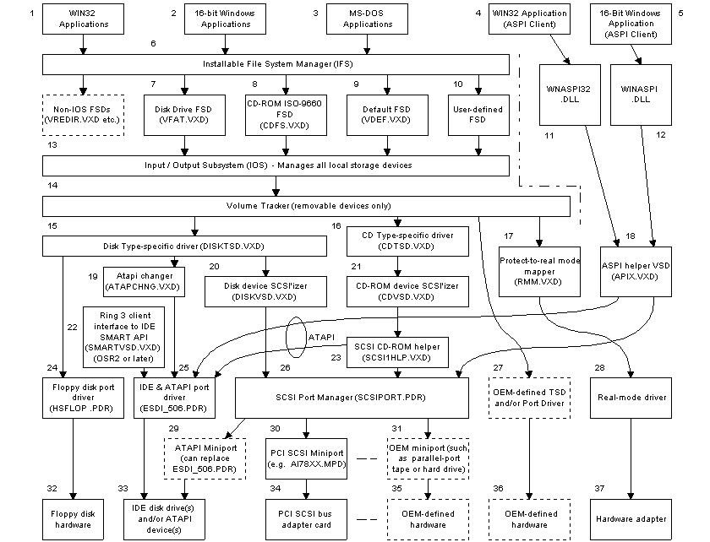
Figure 1 - The Windows 9x/Windows Me Storage Device Driver Model

Port drivers are located at the “bottom” of the IOS hierarchy, closest to the hardware. Most storage technology device driver developers use the SCSI miniport driver model to interface with their hardware (items 30 or 31 in the diagram above).

See the following page for a description of each module.

Module(s) | Comments
1, 2, 3 | These are client applications that use IOS to access all local storage devices.
4, 5, 11, 12, 18 | These modules implement the ASPI specification. ASPI is designed to provide low-level communications (at the SCSI Request Block, or SRB, level) between applications and SCSI miniport devices or (IDE) ATAPI devices. Adaptec provides this technology.
6 | The Installable File System (IFS) oversees storage data at the filesystem level, managing the host File System Drivers (FSDs).
7-10 | File System Drivers (FSDs) manage the format of the file systems contained on storage devices.
13 | The I/O Supervisor (a.k.a. I/O Subsystem), manages storage devices at the physical and logical partition level. It understands storage devices at the “drive number” and “sector number” level.
14 | The Volume Tracker is used to accommodate removable media devices, including PCCARD, USB, SCSI, IDE and ATAPI technologies.
15 | DISKTSD.VXD assigns logical drive letter(s) to each disk-type storage device, when given a physical DCB assigned to the given device.
16 | CDTSD.VXD assigns drive letter(s) to CDROM storage devices, when given a physical DCB assigned to the given device.
17 | RMM.VXD is used to direct I/O to real-mode driver(s), for when there is no functioning 32-bit protected mode device driver for the device.
19 | ATAPCHNG.VXD is installed as needed when a CDROM changer is present.
20 | DISKVSD.VXD is the disk device SCSI’izer, amending its IOP into a full-blown SCSI request (complete with SCSI Request Block).
21 | CDVSD.VXD is the CD-ROM device SCSI’izer, amending its IOP into a full-blown SCSI request (complete with SCSI Request Block).
22 | SMARTVSD.VXD allows a Win32 application to obtain S.M.A.R.T. statistics from IDE disk drives. See Knowledge Base article Q208048 for sample Win32 source code.
23 | SCSI1HLP.VXD inspects CD-ROM I/O requests and compares the request against the manufacturer and model of CD-ROM. It modifies the request if needed, to accommodate special requirements, or correct unusual behavior, of certain CD-ROM devices. In some cases, SCSI1HLP will force SCSI 1 protocol behavior. SCSI1HLP also “helps” ATAPI CD-ROM devices.
24 | HSFLOP.PDR handles floppy diskette drives.
25 | ESDI_506.PDR handles IDE drives and ATAPI devices. ATAPI CDROM and similar ATA devices appear to IOS as if they are SCSI devices, i.e. the IOP packet includes a SCSI Request Block (SRB).
26 | SCSIPORT.PDR supplies the interface to one or more SCSI Miniport device drivers. SCSIPORT implements the Windows NT SCSI miniport standard, orchestrates the loading and initialization of miniport drivers, exports a number of services available to Miniport device drivers, and coordinates I/O between IOS and the miniport driver.
27 | IOS accommodates OEM-defined and developed components, including Vendor Supplied Drivers (VSDs) and Port Drivers.
28 | These are DOS real-mode based drivers that are used until IOS replaces these drivers with their (higher-performance) protected-mode counterparts.
29 | The SCSI Miniport is the most common technique used to develop custom port drivers.  The Windows NT Device Driver Kit supplies a sample ATAPI.SYS miniport driver. This driver sample is binary compatible with Windows 95 through Windows Me. If used, it is renamed to ATAPI.MPD and placed into the %windir%\system\iosubsys directory. This miniport driver can be used to replace much of the functionality of ESDI_506.PDR.
30 | SCSI Miniport drivers, originally developed for Windows NT, are the most common interface to SCSI adapter cards (and the attached SCSI devices) to the rest of the system. A sample functional IDE/ATAPI miniport driver (ATAPI.C) is available in the Windows NT 4 DDK.
31 | SCSI Miniport drivers can also be used to interface Parallel-port based devices such as external tape drives and external hard drives, or to interface unusual hardware, making the device appear as a SCSI device.
Each IOS-supervised driver is located in the %windir%\system\iosubsys folder.

After a driver is dynamically loaded by IOS during its Device_Init phase, IOS sends the SYS_DYNAMIC_DEVICE_INIT message to the control dispatch procedure of the newly loaded driver. The driver responds to this message by registering itself with IOS using the IOS_Register(&DRP) call.

A VxD may reside in the %windir%\system\iosubsys folder and not call IOS_Register. This is generally not good practice if the VxD does not require use of IOS services. If this is done, the DRP declaration must still be used, because IOS expects it to be there when it is dynamically loading the device, even if the device does not use IOS services.

The complete IOS_Register() process is available in Appendix 3 - IOS Registration Flowchart.

All IOS-specific data structures (IDA, DVT, DDB, DCB, VRP etc) and fields within each data structure are detailed in Appendix 2 - IOS internal data structure detail, including a block diagram showing the linkages between the structures.

If you are using the Windows ME debug version of IOS.VXD you can use the IOS dot command .IDUMP for a complete dump of all internal IOS structures, on your debugger terminal.
See Section 7 - Debugging tools for more information.

For more details regarding all the IOS Services, please refer to the “Storage Technology Reference” section of the Windows 98 Device Driver Kit (DDK), downloadable at http://www.microsoft.com/ddk.

Section 5 - SCSI (NT 4) Miniport Driver Topics

This section contains assorted topics of interest to developers of SCSI miniport drivers using the Windows NT 4 Miniport model, targeting the Windows 95 through Windows Me platform(s).

The SCSI miniport interface is the same between Windows NT and Windows 95, and hence the Windows NT 4 DDK’s ATAPI miniport sample, when compiled under NT, works under Windows 95.

Microsoft strongly discourages the replacement of the default Windows 95 (through Windows Me) IDE controller driver, ESDI_506.PDR, with any 3rd-party-developed SCSI Miniport driver. ESDI_506 was designed and has been thoroughly tested to accommodate a wide variety of IDE controllers and storage devices attached to the controller. By replacing ESDI_506 with your own IDE controller driver, storage devices manufactured by other companies might not function correctly.

Therefore, limit your use of SCSI miniport drivers to custom interfaces, as contrasted with generic interfaces such as IDE that accommodate a wide variety of storage devices other than those that you have developed.

There is a strict miniport protocol, designed to be portable (binary code compatible) between systems. This protocol is violated, however, if there are embedded Windows 95 VxDCall(s) or embedded Windows NT system calls within the SCSI miniport driver. Unfortunately, there are a few cases under Windows 95 where VxDCall(s) are necessary, thus breaking binary compatibility. For example, Windows 95’s ScsiPortGetDeviceBase function fails to return a linear address (as described in Knowledge Base article Q169584). This means that the miniport must use a Windows 95 VMM function _MapPhysToLinear to map the physical address to a linear address.

A brief summary of the SCSI Miniport initialization sequence

- IOS calls the miniport's DriverEntry routine as a result of Configuration Manager devnode enumeration.
- The miniport calls ScsiPortInitialize (for each supported bus)
- SCSIPORT.PDR calls IOS_Register as a result of each received ScsiPortInitialize
- IOS_Register presents an AEP_initialize message to SCSIPORT. SCSIPORT creates a DDB, reads miniport ASCII configuration info from registry, and then calls the miniport's HwFindAdapter routine (e.g. FindController). This should occur for each bus.
- IOS_Register creates a temporary "inquiry" DCB and issues an AER_Device_Inquiry for each supported LUN number etc.
- Each instance of step 5 causes SCSIPORT to create an IOP, for a SCSI_PASS_THROUGH inquiry command, and sends it to the miniport’s StartIo routine.
- For each inquiry, the miniport either succeeds or fails. If it succeeds, SCSIPORT sets up the DCB_product_id, DCB_vendor_id and DCB_rev_level into the DCB and returns AEP_success. to IOS.

Steps 2-7 occur for each bus type supported.

Windows NT IOCTL unavailable with Windows 95.

Windows NT uses a miniport IOCTL interface that's not available with Windows 95.

Windows NT allows you to send IOCTL's to SCSI miniports, using CreateFile, and a filespec such as “\\.\Scsi0” and “\\.\c:”. A sample application that uses this technique is found in the Windows NT 4 DDK: \ddk\src\storage\class\spti.

Windows 95 does not support this Windows NT IOCTL technique.

If you want to issue private commands to a (Windows 95) miniport, you can send a SCSI request to it using ASPI16 or ASPI32 (which uses the IOS “SCSI passthrough” message structure). Create a unique function code in the CDB being sent to it, that your miniport can interpret as a custom command. There is sample code in the Windows 95 DDK (\DDK\Block\SAMPLES\WNASPI32, documentation is in \DDK\Docs\DESGUIDE\STORAGE.DOC), which performs simple drive inquiry functions. ASPI is implemented using WINASPI.DLL (for 16 bit apps) or WNASPI32.DLL (32 bit apps) at Ring 3. These DLL's talk to (ring 0) APIX.VXD located in the IOS layered hierarchy. APIX, located at layer 11 of IOS, injects IOR_SCSI_PASS_THROUGH commands into IOS.

Another possible communications technique under Windows 95 is to write a "helper" Vendor Supplied Driver (VSD) that communicates with the user application via (Windows 95) DeviceIoControl(), behaving similarly to APIX.VXD (used by ASPI). The VSD could setup its own private IOP pointing to a private SRB containing the appropriate SRB_FUNCTION_IO_CONTROL function. The VSD could then issue an ILB_internal_request, which sends the IOP request down to the miniport driver.

A sample passthrough VSD, available from the Windows DDK Support Team, is bundled in the following file: PASSTHRU.ZIP (see Appendix 5 - IOS Sample Code). This sample demonstrates how to build the necessary SCSI Passthrough IOP packet. The sample will require changes, for example, in its IOCTL handler, which currently does nothing but will need to be modified to forward requests using ILB_internal_request.

An example of a Win32 application communicating with a generic Windows 95VXD using CreateFile() and DeviceIoControl() is in the Windows 95 DDK, \DDK\Base\SAMPLES\ASYNCW32. This sample, coupled with the Passthrough sample, can be used to create the desired “helper” VSD.

Older Windows NT miniport drivers

Older SCSI miniport drivers written for Windows NT 4 .0 do not include Plug and Play information and, therefore, will not perform well on Windows 95.

Unraveling the Scatter Gather Descriptor (SGD) Confusion

There are two different types of Scatter Gather Descriptors; linear (a.k.a. logical) and physical.

Walt Oney's book Systems Programming for Windows 95 discusses this issue somewhat, on pages 542-543.

Linear SGDs

The linear SGD structure is defined in \ddk\inc32\blockdev.h (as _BlockDev_Scatter_Gather):

typedef struct BlockDev_Scatter_Gather{
ULONG BD_SG_Count;
ULONG BD_SG_Buffer_Ptr;
} _BlockDev_Scatter_Gather ;

A linear SGD consists of a DWORD count followed by a DWORD linear pointer. The count is always assumed to be a block count within SCSIPORT's transfer routines (such as ScsiPortReadPortBufferUchar). Linear SGDs are terminated with a zero length SGD element, but you should use IOR_xfer_count for total length info (this field contains the sector count if IORF_CHAR_COMMAND is not set). The IOP's IOR_buffer_ptr points to a normal linear memory buffer if (IOR_flags & IORF_SCATTER_GATHER)==FALSE. Otherwise, IOR_buffer_ptr points to a simple list of linear SGD's as defined in blockdev.h.

Physical SGDs

The physical SGD structure is defined in \ddk\inc32\sgd.h (as _SGD):

typedef struct _SGD { /* */
ULONG SG_buff_ptr; /* 32 bit physical pointer to the buffer
ULONG SG_buff_size; /* size of the buffer in bytes
} SGD, *PSGD;

The physical SGD structure consists of a DWORD physical pointer followed by a DWORD count (the ordering is reverse that of the linear SGD structure). If the port driver demanded the physical SGD creation service then the DCB_dmd_phys_sgd bit will be set within DCB_dmd_flags.

Inside SCSIPORT.PDR, the ILB_int_io_criteria_rtn is called before forwarding any read/write to the miniport driver. ILB_int_io_criteria_rtn will create physical SGDs if DCB_dmd_phys_sgd is set. In which case, the IOP's IOR_sgd_lin_phys field must point to a valid memory buffer, designed to accommodate the max number of physical SGDs (DCB_max_sg_elements), remembering that each SGD is 8 bytes long. It would be safe to assign (17*8) bytes of memory for IOR_sgd_lin_phys since the maximum number of SGDs is 17.

BufferAccessScsiPortControlled Flag Information.

The Knowledge Base article Q116450, BufferAccessScsiPortControlled Flag Information, describes a mechanism in Windows 95 to improve miniport performance (throughput).

Under Windows 95, if the miniport driver does not report that it supports scatter-gather, then it will only see read requests for one block at a time.

The ScatterGather flag is used to determine if the miniport can handle more than one SGD. If you do not set this flag to true, then SCSIPORT.PDR will assume that the number of SGDs is 1. Typically this will result in your miniport only getting I/O requests for 1 block at a time.

This is obviously a problem for PIO devices, which do not typically support the concept of scatter-gather. In these cases it is possible to force SCSIPORT.PDR to emulate scatter-gather on behalf of your device. This is done by setting BufferAccessScsiPortControlled=TRUE in the PORT_CONFIGURATION_INFORMATION structure in your SCSI miniport.

Please note that this field was originally only documented in the Windows NT 3.5x DDK (it was accidentally omitted from the Win95 DDK documentation). It is however correctly defined in the Windows 95 DDK include files. Also please be aware that it is very important to *not* touch the data buffer directly in your miniport when this flag is set; instead you should only use ScsiPort functions to access the buffer. This is due to the fact that the buffer will not be a linearly contiguous block, but instead will be a list of linear scatter-gather descriptors.

The Master field of Port_Configuration_Information is used to determine if system DMA is required. If SCSIPORT.PDR thinks system DMA is required, it will allocate a 64K physically contiguous block of memory for use as a DMA buffer, and transfer lengths will be limited to 64K. Please set the flag Master=TRUE if you do support bus mastering.

When using BufferAccessScsiPortControlled:

- PIO should work fine, in fact that's what BufferAccessScsiPortControlled is designed for. Bus-mastering devices should not set this field to TRUE.

- Never modify the SRB's DataTransferLength or DataBuffer. The ScsiPort{Read,Write}... functions actually scan through the chained list of SRB's in the system, matching the I/O range against DataBuffer / DataTransferLength of each pending SRB. When found, if IOR_flags.IORF_SCATTER_GATHER is set, IOR_buffer_ptr points to a list of scatter-gather descriptors, and the routine does "emulation" of scatter-gather data transfer, moving data to or from the scatter-gather memory areas. If IORF_SCATTER_GATHER is false, DataBuffer is used directly (it is assumed to be a linear address). Note that within an IOP’s SRB, there is a pointer to its corresponding IOP (SrbIopPointer), which can be used to inspect IOP/IOR fields such as DataBuffer, IOR_flags etc., when debugging.

- ALWAYS use the ScsiPort{Read,Write}Buffer... functions when accessing your buffer.

Here is a brief description of what ScsiPortReadPortBufferUchar (and its generic counterparts) do:

- Scan SCSIPORT's active SRB list, examining the .DataBuffer and .DataTransferLength fields. Attempt to find a buffer that "contains" the memory address requested. If fails, perform the desired transfer between buffer and port, without using IOP / SRB info at all. Then quits.

- Given the SRB, obtain the .SrbIopPointer. Use this to inspect for (IOR_flags & IORF_SCATTER_GATHER). If this bit is clear, perform the desired transfer between buffer and port, without using IOP / SRB info at all. Then quits.

- Here we know we are using linear SGD's. Perform the desired transfer between buffer and port, using the linear SGD's to reference the scattered chunks of memory. When the count has been exhausted, quit. Note that care must be taken to not request too many bytes, since you will run off the end of the SGD list (the code doesn't appear to audit for a zero length SGD element).

How to uniquely identify a specific SCSI adapter in a DCB

A custom VSD, installed within the layered hierarchy of IOS, can uniquely identify a specific SCSI adapter by inspecting the following DCB fields: DCB_port_name, DCB_scsi_hba, and DCB_bus_number.

Dynamic device removal/installation (hot-swapping)

SCSIPORT.PDR, working in concert with IOS, supports hot swapping. In order to detect hardware changes, a custom-written IOS layer VxD can periodically check for hardware insertion or removal. When either event is detected, the custom VxD can call CONFIGMG_Reenumerate_Devnode() at AppyTime. This will cause SCSI device reenumeration. SCSI device reenumeration issues a SCSI Device Inquiry command to all devices associated with SCSI miniports, to detect arrival or disappearance of SCSI physical devices (see Appendix 3 - IOS Registration Flowchart, chart 5 for details).

IOS will detect new devices and devices which have disappeared, and issue the corresponding system messages to make the operating system aware of the device change(s).

If you are developing your own ATAPI miniport driver, you can take the necessary actions within the miniport driver itself when the hardware is inserted or removed. Modify the driver to make sure it completes pending I/O that has become stuck because the hardware was unplugged (or while in the process of plugging the device in). This will avoid causing the system to hang waiting for the orphaned IOP(s) to complete.

In order to locate the devnode associated with the hot-swappable device, one method is to use the SETUPX API DiGetClassDevices to find all instances of the class you are interested in (for SCSI the class is “SCSIAdapter”).

ScsiPortSetBusDataByOffset

This function is intended only for use when first initializing the bus. If you wish to read or write PCI Configuration Space after initialization, refer to Knowledge Base article Q140730 for more information.
This function was missing from the original Windows 95 DDK documentation but can be found in the original header file \DDK\BLOCK\INC\SRB.H.

In SCSIPORT.PDR, this routine actually is simply a wrapper to the following call: CONFIGRET CONFIGMG_Call_Enumerator_Function(DEVNODE dnDevNode, ENUMFUNC PCI_ENUM_FUNC_SET_DEVICE_INFO, ULONG Offset, PFARVOID Buffer, ULONG Length, ULONG 0).

ScsiPortSetBusDataByOffset automatically accommodates non-DWORD granular boundaries by selectively preceding and/or post pending I/O accesses with byte or word granular accesses to PCI config space. Thus you can write one BYTE, one WORD or one DWORD, with the correct I/O data width being issued to the PCI chip.

On obtaining both an I/O range and a memory window from within a SCSI miniport:

If a device has both I/O and memory windows, SCSIPORT will only populate the ACCESS_RANGE array with the I/O windows.

Currently the only work-around for this problem is to read the PCI configuration space directly to get addresses of the memory windows.

Mapping between physical and linear (logical) memory

The following SCSIPORT option flags deal with the usage of physical memory and virtual memory:

Master
If true, during SCSIPORT's CONFIG_DCB, it sets a ceiling on DCB_max_sg_elements to 17. Also if Dma32BitAddresses=0, it sets DCB_dmd_small_memory (used if total memory accessible by bus master device is 16MB or less), and if applicable to the bus type, calls VDMAD_Virtualize_Channel.

MapBuffers
The purpose of this flag is to notify the SCSIPORT manager that all data buffer addresses need to be mapped to virtual addresses, in order to allow the miniport driver access to them.

NeedPhysicalAddresses
This flag causes the following DCB demand bit to be set: DCB_dmd_phys_sgd. When SCSIPORT prepares an IOP, it calls the IOS’s io criteria routine (ILB_int_io_criteria_rtn). If the DCB demand flag DCB_dmd_phys_sgd is set, ILB_int_io_criteria_rtn performs the service of converting the data buffer (or linear SGD list) pointed to by the (linear) IOR_buffer_pointer, into a physical SGD list pointed to by IOR_sgd_lin_phys. See the topic earlier in this section in this titled Unraveling the Scatter Gather Descriptor (SGD) Confusion, for more information.

CDROM and DVD CDROM Issues

Setting the ANSI-approved Version field in the INQUIRY response

You should typically set the ANSI-approved Version field, in the INQUIRY response, to at least 2.

Install the debug version of SCSI1HLP, CDVSD and CDTSD. Check for the following message.
SCSI-I helper VSD found SCSI-1 CDROM, taking over
This indicates that SCSI1HLP believes that an old CDROM drive is being used because the ANSI-approved Version field is less than 2. In the SCSI II Specification for the returned INQUIRY packet, byte offset 2, the first three bits, there is a 3-bit ANSI value field. ATAPI normally returns 0 in this field, but you need to put a 2 in that field. For example, SCSI1HLP.VXD inspects this field to determine whether it needs to "help" the command. The port driver ESDI_506.PDR changes that field to two also.

SCSI1HLP is then installed to allow old legacy CDROM drives (with unusual commands) to work. This will only happen if the INQUIRY command returns a value of less than 2 in the ANSI-approved version field. Thus, new SCSI miniport drivers typically should always set the ANSI-approved version field to 2 or higher.
Note that SCSI1HLP will also load itself if it finds DCB_DEV2_ATAPI_DEVICE bit set (see below), but you won’t see it reported to the debugger.
Additional “Gotchas” for DVD miniport drivers

Details regarding Knowledge Base hotfix article Q197004, “Fatal Exception in CDVSD Starting Windows 98”

For Windows 98, the CDVSD.VXD IOS layer driver has been updated to accommodate DVD-ROM drives. The main CDVSD is at layer 13 (DRP_VSD_5), and a new “timer extender” layer is introduced at layer 14 (DRP_VSD_6) to extend the length of time DVD commands are allowed before a timeout occurs. If a system contains a DVD-ROM drive, there must be no custom VSD’s “chained in” between CDVSD (DRP_VSD_5) and SCSIPORT (DRP_NT_MPD), because the IOS callback routine in CDVSD (label VSD_Callback) depends on the current call down chain pointer to get the address of CDVSD’s DRP. The current call down pointer will point to your custom VSD instead of CDVSD, ultimately resulting in a system crash. If you do not insert your custom VSD into the call down chain, but merely use the VSD to modify DCB structures for example, then this restriction does not apply. This problem has been corrected for Windows 98 Second Edition.

Another restriction is that if you use a custom VSD to set the DCB’s DCB_DEV2_ATAPI_DEVICE flag (more information on this bit is found below), your VSD must be located above SCSI1HLP.VXD in the IOS hierarchy (DRP_VSD_7 or lower), to prevent SCSI1HLP from being loaded and subsequently causing CDVSD’s VSD_Callback code to fail. SCSI1HLP normally is used in conjunction with ESDI_506 to convert SCSI commands to ATAPI and vice-versa, but is not used for DVD-ROM devices. SCSI1HLP automatically loads itself if it sees DCB_DEV2_ATAPI_DEVICE set.

SCSI1HLP can cause further problems with some devices; SCSI1HLP checks to see if MSCDEX is present, and if it is present CDVSD will not take over the CD-ROM drive, since it assumes that the MSCDEX driver will do a better job of dealing with a SCSI-1 CD-ROM drive than our p-mode IOS driver stack will. This leads to serious problems for PCI devices, since they can't share IRQs with real-mode devices.

Supporting Audio CDs

Here's the basic steps for supporting audio CDs in an ATAPI miniport driver:

1) Return an ANSI value of 2 in the INQUIRY data.

2) Convert MODE SENSE and MODE SELECT CDBs from 6-byte to 12-byte CDBs. This involves:
a) converting the 6-byte command value to a 12-byte command value (1Ah to 5Ah, etc.)
b) moving the allocation length value from byte 4 in the CDB to bytes 7-8.
c) zeroing out other CDB bytes above byte 5 (Windows 95 does not zero these out automatically).

3) Upon completing the command, the original CDB must be restored in the SRB. It's probably easiest to store the CDB in the miniport's SRB extension, and restore it when the command completes.

4) Convert the parameter page format from ATAPI to SCSI (for MODE SENSE), and visa versa (MODE SELECT). This essentially means you must convert from an ATAPI format, which looks like this:

8-byte MODE PARAMETER HEADER
n-byte PARAMETER PAGE

..to or from a SCSI-2 format, which looks like this:

4-byte MODE PARAMETER HEADER
8-byte MODE BLOCK DESCRIPTOR
n-byte PARAMETER PAGE

Please note that this means that the allocation length in the CDB will need to be increased or decreased by 4-bytes to account for the differences in the size of the parameter headers for SCSI-2 and ATAPI.

5) Track the current block size for the CD-ROM drive, and return the correct logical block size in the block descriptor for MODE SENSE commands.

When CDVSD issues a MODE SENSE command, it is looking for a non-zero value in the block length field of the block descriptor. When it finds a non-zero block length (which apparently indicates support for changeable block size), it will issue the same MODE SENSE command again, for current values rather than changeable values. In this case it will expect the current block size for the device to be listed in the block length field (2048 or 2352 bytes). The ATAPI miniport must keep track of the current block size as given in the MODE SENSE commands (2048 is the default), and return this value in the block descriptor for MODE SENSE commands.

6) Insure that ScsiStatus is set to zero when a data underrun occurs. The NT 4 ATAPI miniport sample may not always do this correctly.

Using the DCB_DEV2_ATAPI_DEVICE bit

The port driver ESDI_506.PDR sets the DCB bit DCB_DEV2_ATAPI_DEVICE for the IDE ATAPI CD-ROM device that it controls. SCSI1HLP detects this bit during CONFIG_DCB time and chains itself into all IOPs directed at that device. When such a SCSI command is received by SCSI1HLP, it translates the command between SCSI and ATAPI packet formats so ESDI_506 sees only ATAPI commands. SCSI1HLP also translates ATAPI back to SCSI. When writing a SCSI miniport driver to replace the functionality of the ESDI_506 driver, this bit can be set by a custom VSD, subject to the restrictions discussed earlier in this section.

Implementing Atapi CD-Changer (using DCB_DEV2_ATAPI_DEVICE)

The ATAPI changer driver shipped in OSR2 and Windows 98 is designed to work explicitly with ESDI_506.PDR. Specifically, it will look for the DCB_DEV2_ATAPI_DEVICE flag in the DCB created for the CD-ROM drive. This flag is never set if the IDE controller is using a SCSI miniport instead of
ESDI_506.PDR. The ATAPI changer driver will also explicitly look for a SCSI miniport name of IDEATAPI.MPD if the DCB_DEV2_ATAPI_DEVICE flag is not set. If neither of these conditions are met, the ATAPI changer driver will not get loaded.

Given this, you have a few options to support ATAPI changers:

1) You can write a small VSD that sets the DCB_DEV2_ATAPI_DEVICE for ATAPIdevices controlled by your SCSI miniport.

2) You can use the name "IDEATAPI.MPD" as your miniport name.

3) You can implement all the changer functionality in your SCSI miniport. This would involve returning INQUIRY data for each platter on the ATAPI changer (LUN0, LUN1, etc.). You would need to manage changing platters, etc. in the miniport driver itself.

Recommended MaximumTransferLength

If an IOS request's block size is greater than the SCSI miniport driver’s MaximumTransferLength, IOS will “double buffer” to accommodate your limits (“IOSSERV: request too big, so double buffering”). This is normal. However, when it double buffers, it breaks the requests down into 4K pieces, which results in some performance degradation. If you set MaximumTransferLength to 64K or larger, and a request is bigger than that, IOS will attempt to break the request into 64K chunks (instead of 4K). So for performance reasons you should consider using a 64K (or larger) maximum transfer length.

A small max transfer size causes IOS to massively double-buffer I/O requests. Under rare circumstances this can lead to an attempt to reenter VMM's memory manager, which causes a deadlock. The recommended corrective action is to set MaximumTransferLength to 64K or larger.

The function that determines whether to double buffer is ILB_int_io_criteria_rtn (the latest info is found in the Windows 98 DDK help documentation) This routine is called in SCSIPORT just prior to SCSIPORT calling the IOS_Send_Command function. ILB_int_io_criteria_rtn returns with error if any of the various required criteria fail. It returns an error if any of the following are true:

- the original request length is greater than the max transfer length supported by your miniport driver’s DCB_max_xfer_len (which is ConfigInfo->MaximumTransferLength).
- the buffer address OR buffer length fails address alignment criteria
- IOS is unable to generate physical SGDs (if so requested) given the setting for the maximum number of physical breaks

SCSIPORT performs the above criteria call on behalf of your miniport driver. If SCSIPORT sees that the criteria routine fails, its sets the following flag: IORF_DOUBLE_BUFFER. SCSIPORT then calls IOS_Send_Command. This flag is looked at and eventually cleared in IOS_Send_Command. If it is set, IOS_Send_Command will double buffer the call (break the buffer into smaller pieces and ensure they are aligned okay). This can happen even if the
transfer length is short, in the case of alignment criteria failure.

Developing a Multifunction INF file

An adapter card that contains multiple bus controllers requires a Multifunction INF file. See Knowledge Base article Q242348 - SAMPLE Ideinf.exe: Architecture of the .inf File for Windows 9x Dual IDE Controllers for additional information.

The Extended IOP Structure

The following figure illustrates the structure of a typical “extended IOP” used when performing SCSI operations. Drivers that talk directly to SCSI devices (SCSI Passthrough) need to create this structure. The ordering of certain items within the extended IOP, such as the SGD list and the sense info, may vary. For example CDVSD locates the PORT_SRB, SRB extension and sense info into the DCB expansion area, not at the end of the IOP packet as shown below.

IOP contents | Component size | Comments
DCB expansion area | DCB_expansion_length
IOP/IOR | Size IOP | The combined IOP+IOR structure
Physical SGD list | DCB_max_sg_elements * 8 | IOR_sgd_lin_phys points to this list. Required when target hardware requires physical addresses (such as a bus mastering device).
PORT_SRB | size PORT_SRB | Contains base SRB plus miniport SRB extension
SRB extension | DCB_srb_ext_size | Contains Adapter port extension (APEXT) plus per-miniport-adapter memory area (miniport-requested per-request state info)
Sense info buffer | VSD_REQ_SENSE_SIZE | Set the SRB's .SenseInfoBufferLength to this size

Additional Differences in SCSI between Windows 95 and Windows NT 4

First refer to the Knowledge Base articles dealing with implementation differences between Windows 95 and Windows NT 4. Some of these articles are listed at the end of this section.

Plug and Play

The only major difference between the two is support for Plug and Play under Windows 95. In Windows 95 the PORT_CONFIGURATION_INFO structure will already be populated with the system resources (I/O and memory ranges, DMA channel, etc.) assigned to the controller. In this case the miniport is expected to not “sniff” for the controller.

You might consider setting flags in your code to accomplish conditional compilation (to accommodate both Windows NT and Windows 95).

Using the ATAPI miniport driver sample located in the Windows NT 4 DDK

A common issue deals with the Windows 95 IDE/ATAPI port driver (ESDI_506.PDR). Microsoft does not supply the source code of ESDI_506.PDR. However, Microsoft DOES supply the source code for an ATAPI miniport driver in the Windows NT 4 DDK. This driver may be used to replace the functionality of ESDI_506. Windows NT SCSI miniport drivers are generally binary compatible with Windows 95 through Window Me (there are minor differences, for example, Windows NT supports miniport iocontrol commands that are not supported by Windows 95).

SCSI miniport driver devices support dynamic re-enumeration (hot-swapping), while the ESDI_506.PDR driver does not. If you want to accommodate “hot” device removal and reinstallation, you can modify the miniport driver to detect the addition and removal of the hardware, and call CM_Reenumerate_Devnode(), to force the system to re-enumerate the bus (which detects both removal and arrival of devices). Part of the IOS SCSI reenumeration process is to issue device inquiries to identify new device(s) and obtain the SCSI device's hardware ID. The .INF files are scanned to find a hardware ID match. If a match is found, the "new hardware" popup menu is avoided, and the process automatically completes.

Here is the general process for setting up the Windows NT ATAPI miniport sample into Windows 95:

- Inspect the file named scsi.inf located in the <windows directory>\inf\ path (or do a grep for "mpd" in the inf\ path). You'll find two different types of entry, here are some examples:

CopyFiles=@ncr53C9x.mpd
...
HKR,,PortDriver,,ncr53C9x.mpd

The first item causes the miniport driver (.mpd) to be copied to the %windir%\system\iosubsys\ path. The second item adds the name of the miniport driver to your entry in the registry. You need to amend scsi.inf to contain your new atapi.mpd, or create your own INF file.

- You can test your miniport driver by manually copying it to the \iosubsys\ path (renaming your binary file atapi.sys to atapi.mpd), and going into the registry, renaming ESDI_506.PDR to the name of your miniport driver (atapi.mpd). Note that special steps need to be taken when overwriting system files under Windows Me. Refer to the Windows (Me) DDK for details, or alternatively you can perform the file copy after booting the system using the Emergency Boot Disk (EBD).

- For Windows 95, you don't need any other Windows NT files. Windows 95 uses its own port driver, SCSIPORT.PDR to interface your miniport driver.

Miscellaneous Questions and Answers

Q: While executing code in the HwInterrupt() function of my miniport, if I do something that causes another h/w interrupt, will the O/S call my HwInterrupt() function again?

A: VPICD will actually mask off the interrupt at the PIC before it calls the installed interrupt handler (SCSIPORT.PDR, in this case). This means that your HwInterrupt() procedure will not be re-entered if it causes an interrupt to occur. To be safe, make the assumption that HwInterrupt() would be called again after you return from HwInterrupt(). This would occur after SCSIPORT.PDR has physically unmasked the interrupt at the PIC, since your device is still asserting an interrupt to the PIC and the PIC was EOI'd by VPICD before the original HwInterrupt() call.

It should also be noted that SCSIPORT.PDR executes an STI before calling HwInterrupt(), so other interrupts will continue to be serviced while HwInterrupt() is executing.

Q: How can I send a user-defined parameter string to the miniport?

A: See the following Knowledge Base article for the answer to the above question: Q140728 AdapterSettings Entry for SCSI Miniport under Windows 95.

As an example, the AddReg section for the NCRC810 (found in \windows\inf\scsi.inf) looks like this:

[NCRC810.reg]
HKR,,PortDriver,,ncrc810.mpd

If you wished to add an AdapterSettings string, you would simply do this:

[NCRC810.reg]
HKR,,PortDriver,,ncrc810.mpd
HKR,,AdapterSettings,,"This is the Adapter Settings string passed to HwFindAdapter"

This string would be added to the software branch of the registry for this device. If you want to the AdapterSettings string to be added to the device's key in the hardware branch of the registry, you can specify a Hardware Section in your INF to do this. This is useful if you want end-users to be able to modify the string via the 'Settings' property page for the device.

To add a Hardware Section, you simply add a ".HW" extension to the install section name used for your device. For example, the NCRC810's install section looks like this:

[NCRC810]
CopyFiles=@ncrc810.mpd
AddReg=IOS,NCRC810.reg
UpdateInis=DoubleBuffer

You create a separate hardware section in your INF by adding a .HW extension to the name of your install section. You can then specify a AddReg section that adds the AdapterSettings subkey:

[NCRC810.HW]
AddReg=NCRC810.HW.reg

[NCRC810.reg]
HKR,,AdapterSettings,,"This is the Adapter Settings string passed to HwFindAdapter"

Q: My SCSI miniport supports Auto Request Sense. What SCSI status should be returned to SCSIPORT -- the status of the original command that failed (check condition) or the status of the request sense that just happened (good status)? Currently, they are returning good status. Seems to work fine on Windows NT and Windows 95 for the most part. However, on Windows 95 when using ASPI we are seeing a good status returned to the application, but they think they should see a check condition.

A: Once the request sense has successfully completed, you should return an SrbStatus of SRB_STATUS_ERROR and SRB_STATUS_AUTOSENSE_VALID, and a ScsiStatus of SCSISTAT_CHECK_CONDITION.

Q: Can I assign a floppy disk drive letter to a SCSI Miniport driver?

A: Under Windows 95, a miniport driver, by itself, is not capable of assigning to drive A or B. A miniport drive can be assigned as "removable", but not as a "floppy disk".

The actual drive letter assignment is performed by the "Disk TSD" (DISKTSD.VXD) in the middle layer of the IOS hierarchy. Each time it receives the AEP_CONFIG_DCB message, it inspects the DCB. If it is a hard disk or floppy disk (which includes floptical), it inserts itself into the IOS "calldown chain" and assigns a drive letter using IOS' ISP_ASSOCIATE_DCB service.
This service inspects real-mode drivers; the real-mode drive letter assignment affects the assignment of drive letters in protected mode. DISKTSD also handles the situation where a single floppy disk drive appears as both drive A and drive B.

If the floppy disk device is an IDE LS120 (or any floptical type) driver, used with Windows 95 version B (OSR2) or higher, note that DISKTSD checks the DCB field DCB_device_flags2 to detect this by inspecting the following bit: DCB_DEV2_IDE_FLOPTICAL_BIT. This bitmask flag is not defined in the original Windows 95 DDK; its value is 0x00000040. If it is set, it indicates the device is a floptical device. DISKTSD then issues an IOR_COMPUTE_GEOM to the device, in order to obtain the correct disk geometry information.

Miniport drivers communicate through the scsiport port driver (SCSIPORT.PDR). Unfortunately, the miniport interface does not provide the miniport with information such as DCB_DEV2_IDE_FLOPTICAL_BIT and other such internals.

If you need to reassign drive letters, and you want to keep using your miniport driver (instead of writing your own port driver), you might try writing a custom TSD (type-specific driver) that is installed into the layered hierarchy of IOS (like DISKTSD.VXD, but placed "below" DISKTSD, closer to port drivers).

The custom TSD could be used to change drive letter assignments. Perform similarly to DISKTSD (respond to AEP_CONFIG_DCB messages).

- In general, use the ISP_GET_DCB service to locate devices. Supply the desired drive letter as input. Returns a pointer to the corresponding DCB.
- If inspecting a floppy disk drive A, check its DCB to see if it is used as both Drive A and Drive B (check DCB_dmd_do_a_b_toggling). If it is set, clear it. This will allow you to use drive B.
- Use the ISP_DISASSOC_DCB to "disassociate" the drive letter (for example drive B)
- Locate the drive letter currently assigned to your drive (using ISP_GET_DCB).
- Use the ISP_ASSOCIATE_DCB to assign your drive to drive B.
- Use the ISP_DISASSOC_DCB to deassign the former drive letter of your drive (for example drive D)

A sample driver is located at \DDK\Block\SAMPLES\VSD\HELPVSD\ in the Windows 95 DDK. A TSD is a VSD that has the special function in the IOS layered hierarchy of assigning drive letters (among other things). The sample's vsd_config_device() entry point is where DCB(s) need to be inspected and modified as required. The compiled TSD belongs in the %windir%\system\iosubsys\ directory (along with other IOS layer drivers).

The DDK contains documentation describing how to setup the compile environment. The easiest and quickest technique is to use the batch file DDKENV.BAT to establish your environment (DDKENV 32 BLOCK), then change to the source code directory, then run "nmake".

Q: How does Windows 95’s ScsiPortGetPhysicalAddress work?

This SCSIPORT service is used to enable the miniport driver to obtain a physical address, given a data buffer’s linear address. Under Windows 95 (NOT Windows NT), the process is as follows:

- If (Srb != NULL) && (VirtualAddress lies within the Srb's DataBuffer) scan the corresponding IOP's IOR_sgd_lin_phys field to obtain the desired SG element and physical offset within that element. The returned length is the number of bytes from the offset within the SG element, to the end of the SG element.

(else)

- If (VirtualAddress lies within the IOP Memory Pool)
The physical address is obtained by finding the offset within the memory pool and adding IDA_ios_mem_phys to the offset value. The returned Length is ALWAYS 4096.

(else)

- _CopyPageTable(VirtualAddress/4096, 1, Pte, 0).
PhysAddr = (Pte & 0xFFFFF000) + (VirtualAddress & 0xFFF).
Pte is the Page Table Entry as described in the Pentium Processor Users Manual Volume 3.
The returned Length is ALWAYS 4096.

Based on the above info, one cannot always rely on the returned Length containing the correct length; it may be longer than the actual buffers.

In general, if the SRB pointer supplied is good, and the VirtualAddress is within range of the SRB's DataBuffer, taking into account DataTransferLength, then the returned length makes sense (within the physical SGD associated with VirtualAddress). Otherwise, the returned length field will contain a fixed 4096 byte value, which probably shouldn't be used when performing total length calculations.

Q: How do I interpret the “problem number” listed in the Device Manager, when a device is not working properly?

A: The problem number displayed is actually a configmg problem number, and can be found in CONFIGMG.H in the Windows 95 DDK. (the CM_PROB_xxx error codes). Be sure to keep in mind that Device Manager displays this number in decimal, while CONFIGMG.H #defines are in hex.

Additional SCSI Reference Material

The following reference material can be useful to SCSI Miniport developers:

- Microsoft Windows 95 Device Driver Kit (supplied to MSDN subscribers)
- Microsoft Windows NT 4 Device Driver Kit (supplied to MSDN subscribers). Contains SCSI miniport information relevant to Windows 95 SCSI miniport development as well.
- Systems Programming for Windows 95, by Walter Oney (Microsoft Press).
See his web site for errata: http://www.oneysoft.com.
- The SCSI Bus and IDE Interface, by Friedhelm Schmidt (Addison-Wesley) ISBN 0-201-42284-0.
- Microsoft support web site:
http://support.microsoft.com/support
- For Windows 95 DDK samples & tools:
http://support.microsoft.com/support/ddk

Assorted Knowledge Base Articles for Windows 95 SCSI Miniports

Q116450 BufferAccessScsiPortControlled Flag Information
Q140728 AdapterSettings Entry for SCSI Miniport under Windows 95
Q140730 Accessing PCI Device's Configuration Space from Device Driver
Q140732 PRB: Windows 95 Doesn't Load SCSI Miniport Driver
Q160667 Miniport Driver Fails Using Certain ScsiPort APIs
Q163358 PRB: DDKDEBUG.BAT Copies Some Drivers to the Wrong Directory
Q169584 BUG: Win95: ScsiPortGetDeviceBase Does Not Return Linear Address
Q242348 SAMPLE Ideinf.exe: Architecture of the .inf File for Windows 9x Dual IDE Controllers

Assorted Knowledge Base Articles for Windows NT SCSI Miniports

Q113706 How to Pass Parameters to a SCSI Miniport via the Registry
Q126369 FIX: Large Transfers Via SCSI Passthrough May Crash System
Q137247 IOCTL_SCSI_MINIPORT and IOCTL_SCSI_PASS_THROUGH Limitations
Q140269 PRB: SCSI Miniport Adapter-Specific Parameter May Be Incorrect
Q140610 BUG: SCSI Miniport Parms Not Parsed on Multi PCI Bus Systems
Q140268 SCSI Miniport's Use of the SRB DataBuffer

Section 6 - IOS Port Driver Topics

This section addresses common questions that arise when developing an IOS port driver.

An IOS port driver is not to be confused with a SCSI Miniport driver; the SCSIPORT.PDR IOS Port driver serves as the host to accommodate SCSI miniport drivers.

IOS Port Driver general theory of operation

A skeleton port driver code sample is located in the Windows 95 DDK at \DDK\Block\SAMPLES\PORT. Also, refer to the following book, which includes a CD-ROM containing a sample RAMDISK IOS Port Driver:

Title | Author / (Publisher) | ISBN | Comments
Systems Programming for Windows 95 | Walter Oney (Microsoft Press). | 1-55615-949-8 | See his web site for book errata and DDK annotations: http://www.oneysoft.com

Here is the general process that should occur when an IOS port driver receives a new IOP. Note it is assumed that the port driver is connected to a piece of hardware.

- The port driver checks to see if the hardware is already busy performing I/O. If it isn't, go to step 2 below. If it is (busy), it enqueues the new IOP using ILB_enqueue_iop. This function is used to serialize I/O requests for your port driver. After the enqueue, the driver does a simple return (no IOS IOP_callback_ptr callback).
Microsoft's ESDI_506.PDR source code uses the CLI instruction before the ILB_enqueue_iop:
cli ; avoid race
push esi ; *DCB
push ebx ; *IOP
call [esdi_ilb].ILB_enqueue_iop ; queue the request.
add esp, 4+4
STI is used afterwards. This is a precautionary measure to prevent re-entrant thread problems.

- At this step, the hardware is not already busy, so the driver starts I/O for the device. Normally at this step, the port driver is going to have to wait for hardware to respond. If the hardware polling method is used (instead of waking up when an interrupt arrives), the driver then calls Set_Global_Time_Out or Set_Async_Time_Out so that the driver's timeout (polling handler) routine gets called back later, for example in 10 milliseconds. Immediately after this Set_Global_Time_Out call, simply return (WITHOUT doing a JMP to the IOP_callback_ptr routine). This releases the system from your driver, so the system can run normally for a while.

- After a time (for example 10 milliseconds), your polling handler gets called when the global timer times out. Your handler checks your hardware's status. If the hardware has not completed, re-issue a global timeout so the hardware can be checked again (10ms) later. If the hardware has completed, finish the I/O, and CALL (not JMP to) the IOP_callback_ptr routine. This has the effect of handing the IOP back to IOS in order to truly complete the request. Next, call ILB_dequeue_iop to see if there are any queued IOP's. If there are, take the new IOP, and jump to step 2 above, to start a new I/O. If there are no enqueued requests, do a simple return.

If hardware has an associated hardware interrupt, the procedure is more efficient because the driver doesn't have to poll the hardware.

The sample port driver in the Windows 95 DDK (\DDK\Block\SAMPLES\PORT) demonstrates enqueueing and dequeueing of IOPs.

IOP Serialization

When set, the bit DCB_DEV_SERIAL_CMD in dcb_device_flags instructs IOS to add a special entry into the calldown stack for the DCB (after the port driver gets its AEP_CONFIG_DCB call). The call is to a routine named IOS_serialize. This is used internally only, to support real mode devices and blockdev (Win 3.1 Fastdisk (32-bit ring 0 ) drivers).

The source code for IOS_serialize (below) is enlightening, since it demonstrates use of queueing and dequeueing. Your port driver should do its own enqueueing via ILB_enqueue_iop etc. Study the code below to help understand IOP queuing mechanics. Note that if you write a VSD (Vendor Supplied Device), residing in the IOS layered hierarchy between IOS and the port driver, and your VSD needs to enqueue IOPs, you cannot use ILB_enqueue_iop because it is reserved for use by port drivers. Instead, your VSD will need to implement a private queuing mechanism.

You may have noticed the flag DCB_dmd_serialize in the header file DCB.H. This flag is never used.

;;;;;;;;;;;;;;;;;;;;;;;;;;;;;;;;;;;;;;;;;;;;;;;;;;;;;;;;;;;;;;;;;;;;;;;;;;;;;
; IOS_serialize
; Routine serializes all I/O to a physical device
; INPUT: *IOP on stack
; OUTPUT: none
; USES:
;;;;;;;;;;;;;;;;;;;;;;;;;;;;;;;;;;;;;;;;;;;;;;;;;;;;;;;;;;;;;;;;;;;;;;;;;;;;;

BeginProc IOS_serialize, esp
ArgVar IOPPtr, DWORD

EnterProc
SaveReg <edi>

mov eax, IOPPtr
AssertIOP <eax>
mov edi, [eax].IOP_physical_dcb

;
; insert in callback stack
;

mov edx, [eax.IOP_callback_ptr] ; set CB
mov [edx.IOP_cb_address],offset32 IOS_serialize_callback
add [eax.IOP_callback_ptr],size IOP_callBack_entry ; move down

AssertDCB <edi>

;
; enqueue the IOP
;

push edi
push eax
call IOS_enqueue_iop
add esp, 8

call IOS_bd_send_next_command

IOS_s_exit:
RestoreReg <edi>

LeaveProc
Return

EndProc IOS_serialize

;;;;;;;;;;;;;;;;;;;;;;;;;;;;;;;;;;;;;;;;;;;;;;;;;;;;;;;;;;;;;;;;;;;;;;;;;;;;;
; IOS_serialize_callback
; Completion routine for request serialization
; INPUT: *IOP on stack
; OUTPUT: none
; USES:
;;;;;;;;;;;;;;;;;;;;;;;;;;;;;;;;;;;;;;;;;;;;;;;;;;;;;;;;;;;;;;;;;;;;;;;;;;;;;

BeginProc IOS_serialize_callback, esp

ArgVar CBIOPPtr, DWORD

EnterProc

SaveReg <esi, edi>
mov esi, CBIOPPtr
AssertIOP <esi>

mov edi, [esi].IOP_physical_dcb
AssertDCB <edi>

mov ecx, [esi].IOP_callback_ptr ; get our callback ptr
sub ecx, size IOP_CallBack_Entry ; point to next available
; callback entry
mov [esi].IOP_callback_ptr, ecx ; update CallBack Pointer

;IOP pointer is passed on the stack

push esi ; IOP's offset
call [ecx].IOP_cb_address ; make the call
add esp, 4 ; restore stack

AssertDCB <edi>

;
; dequeue the next request
;

ASSERT_INTS_ENABLED
cli
cmp [edi].DCB_BDD.DCB_BDP_Current_Command, 0
je IOS_sc_send_next

cmp esi, [edi].DCB_BDD.DCB_BDP_Current_Command ; Is this the
current cmd?
jne ios_sc_exit

mov [edi].DCB_BDD.DCB_BDP_Current_Command, 0 ; No current
command!

IOS_sc_send_next:
call IOS_bd_send_next_command

IOS_sc_exit:
sti
RestoreReg <edi, esi>
LeaveProc
Return

EndProc IOS_serialize_callback

;;;;;;;;;;;;;;;;;;;;;;;;;;;;;;;;;;;;;;;;;;;;;;;;;;;;;;;;;;;;;;;;;;;;;;;;;;;;
; Starts the next request for a device
; ENTRY edi => DCB
; ints disabled
; EXIT ints enabled
;;;;;;;;;;;;;;;;;;;;;;;;;;;;;;;;;;;;;;;;;;;;;;;;;;;;;;;;;;;;;;;;;;;;;;;;;
BeginProc IOS_bd_send_next_command

AssertDCB<edi>
cmp [edi].DCB_BDD.DCB_BDP_Current_Command, 0
jne short ios_snc_exit

push edi
call IOS_dequeue_iop
add esp, 4

or eax, eax
jz IOS_snc_exit

AssertIOP <eax>
mov [edi].DCB_BDD.DCB_BDP_Current_Command, eax

sti
SaveReg <esi, edi, ebx>

lea edi, [edi].DCB_BDD ; (edi) = BDD
mov ecx, [eax].IOP_calldown_ptr ; call down the request
mov ecx, [ecx].DCB_cd_next ; get next entry
mov [eax].IOP_calldown_ptr, ecx ; store in IOP

push eax ; place IOP pointer on stack
call [ecx].DCB_CD_IO_Address ;
add esp, 4 ; call next layer down

RestoreReg <ebx, edi, esi>

IOS_snc_exit:
sti
ret

EndProc IOS_bd_send_next_command

What are the rules for making a R0 read/write call from an IOS port driver?

Conventional IFSMGR_Ring0_FileIO typically will not work when called from within an IOS port driver if attempting to open and use a file located on a local (FAT) drive. This is because of blocking that can occur in VFAT. VFAT uses IFSMGR_Block to serialize use of FAT data structures (and prevent VFAT data structure corruption due to re-entrance). Also there is a flag in VFAT called FullHold, which keeps track of the count of threads in VFAT and establishes a "full critical section" that is VFAT-global (not specific to a single drive letter). Attempts to perform IFSMGR_Ring0_FileIO fail (block) when called from a port driver, since the original port request went through VFAT; the subsequent Ring0 file call gets blocked by FullHold. However, success has been reported by developers outside of Microsoft, if the file is opened as a memory mapped file, under Windows 95 through Windows 98. With memory mapped files, IFS Manager performs fewer tests for sharing violations. Therefore you should set up a private memory-mapped file so it is not opened by any program other than yours. Also, all your I/O requests should be page (4K) aligned.

The following code, extracted from VWIN32, is used to read a memory-mapped file on behalf of Kernel32:

mov eax,R0_READFILE or (R0_MM_READ_WRITE shl 16) ; (eax) = read/write
mov al,byte ptr [function] ; (al) = read (3f) or write(40)
sub al,3fh ; (al) = read (0) or write (1)
xor ecx,ecx
mov edx,[fileloc] ; (edx) = seek position
mov ecx,[cbLen] ; (ecx) = number of bytes in i/o
mov esi,[memloc] ; (esi) = transfer address
VxDCall IFSMgr_Ring0_FileIO ; do the i/o
Trace_OutC "ReadWritePage: error #EAX from file i/o"

Note that the R0_MM_READ_WRITE flag must be set for every I/O operation, not just at file open time.

As long as we are discussing Ring0_FileIo, here is how PAGEFILE VXD opens the swap file (after it has been determined that the swap file can be safely accessed by 32-bit protected mode drivers):

; Open or Create the file

mov eax,R0_OPENCREATFILE ; (eax) = open function code
mov bx,0110000010010010b ; (bx) = flags: r/w, deny all,
; no inherit, no int 24,
; no caching
xor ecx,ecx ; (ecx) = attributes (nothing)
mov dl,00010001b ; (dl) = open mode, open or create
mov dh,((R0_SWAPPER_CALL or R0_NO_CACHE or OPEN_FLAGS_NO_COMPRESS) SHR 8)
; (dh) = special flags
mov esi, offset32 PF_Our_File_Name ; (esi) = file name
VxDCall IFSMgr_Ring0_FileIO ; do the open (eax) = handle
jc osf110 ; jump if error

mov [PF_File_Handle],eax ; save file handle

The original Windows 95 DDK did not mention that the flag bits need to be shifted right 8 positions as shown above. Read/write of the swap file are performed using normal R0_READFILE and R0_WRITEFILE functions, with no special flags set.

Here is a reportedly successful implementation of an IOS port driver that uses the above R0_MM_READ_WRITE Ring0_FileIo to access a local FAT file:

- Open the file with the following flags: R0_OpenFile(R0_NO_CACHE | R0_MM_READ_WRITE)
- CreateSemaphore()
- VWIN32_CreateRing0Thread()
- Set_Thread_Win32_Pri(16) - other values may work
- Set a worker thread running:
Thread()
while not stop
Wait_Semaphore(BLOCK_THREAD_IDLE)
Dequeue IOP
Do R0 file I/O
Do CallBack
endwhile
- The IOP Handler:
IOHandler(IOP)
if read or write
Enqueue IOP
Signal_Semaphore()
return
endif

Also, the developer reported the need to do periodic forced volume flushes to the memory mapped file (virtual drive) when a long file is being copied to it. This is done using IFSMGR_InstallFileSystemApiHook. Upon write operations to the virtual volume a data byte counter is incremented, and direct calls to volume's flush function through its function table occur, if the counter = 1Mb. Without this, the reading of the file from system volume slows down and would ultimately result in being locked up in Ring0_FileIo.

When R0_NO_CACHE is used, the system doesn't do any buffering during I/O. For example, the buffer address goes directly to the ESDI port driver.

How does Windows 95 itself use IFSMGR_Ring0_FileIo?

The following is an abbreviated analysis of how Windows 98’s DriveSpace (DRVSPACX) accesses its host Compressed Volume Files (CVF’s) located on the physical host volume.

- DRVSPACX only uses the IFSMGR_Ring0_FileIo call when it is handling the AEP_MOUNT_NOTIFY event, in order to find and read the beginning part of all the CVF's (Compressed Volume Files) on a CVF host drive. This event is generated by IOS when IRS_MOUNT_NOTIFY is called. When performing these actions, there doesn't appear to be any special blocking / serialization going on.

- Whenever DRVSPACX does use IFSMGR_Ring0_FileIO to read a CVF (see above), it uses the R0_READFILE_IN_CONTEXT flag.

- For normal compressed volume file I/O, DRVSPACX sets up an IOP and performs direct sector I/O. DRVSPACX apparently automatically accounts for any fragmentation that the file may have on the disk, and knows the starting sector for each CVF file.

A global search for IFSMGR_Ring0_FileIO across the Windows 98 source tree reveals the following:

- DYNAPAGE.VXD still uses it. It appears to be used when creating, auditing or resizing the swap file.

- IOS uses IFSMGR_Ring0_FileIO during initialization when loading VxDs from the %windir%\system\iosubsys directory.

Q183173 BUG: IFSMGR_Ring0FileIO / Level 3 Volume Lock Conflict

There is a bug in IFS that affects VxDs that use IFSMGR_Ring0_FileIo. The corresponding Knowledge Base article (Q183173) is reproduced below. Use the on-line Knowledge Base to check for later potential updates to this article.

The article :BUG: IFSMGR_Ring0FileIO / Level 3 Volume Lock Conflict [win95ddk]
can be accessed at this location:
HTTP://SUPPORT.MICROSOFT.COM/SUPPORT/KB/ARTICLES/Q183/1/73.asp
[Q183173] BUG: IFSMGR_Ring0FileIO / Level 3 Volume Lock Conflict
---------------------------------------------------------------------
The information in this article applies to:

- Windows 95 Device Driver Kit (DDK), version 4.0

SYMPTOMS

If you are using IFSMGR_Ring0FileIO services, you might encounter file access problems when you run utility programs, such as DEFRAG, while IFSMGR_Ring0FileIO files are open.

For example, a file opened as ACCESS_READ_WRITE works fine, until you run DEFRAG. After you run DEFRAG, the file attributes erroneously change to ACCESS_WRITEONLY.

CAUSE

There is a bug in IFSMGR_Ring0FileIO that becomes apparent only when a level three volume lock is released and, as a result, the volume release automatically causes the ring 0 file to be re-opened. When the file is re-opened, the file access mode is erroneously set up with the contents of the file action type. For example, a file opened as follows:

mov esi, OFFSET32 R0_szFileName
mov ebx, ACCESS_READWRITE ; 0x0002
xor ecx, ecx
mov edx, ACTION_OPENEXISTING ; 0x0001
mov eax, R0_OPENCREATFILE
VxDCall IFSMgr_Ring0_FileIO

is re-opened with the contents of EDX appearing in EBX. When appearing in EBX, the value ACTION_OPENEXISTING (0x0001) corresponds to ACCESS_WRITEONLY (0x0001).

RESOLUTION

When the level 3 volume lock is released, it re-opens the temporarily-closed files using FS_OPEN calls down to the target FSD (typically VFAT). You can hook IFS using IFSMgr_InstallFileSystemApiHook to correct "reopen" FS_OPENs on the fly before the FSD sees it. To see if a given FS_OPEN is actually a reopen due to a level 3 volume lock release, check for (ir_options & OPEN_FLAGS_REOPEN). In the Windows 95 Device Driver Kit, see header file IFS.h for flag details. When you find one of these, you can further test for ir_pid = -1, which corresponds to a file opened using the ring 0 functions. Change ir_flags to the correct file access method. For example, if ir_flags erroneously contains ACCESS_WRITEONLY, change it to ACCESS_READWRITE. Then let the file-system I/O proceed normally to complete the (corrected) file open.

STATUS

Microsoft has confirmed this to be a bug in the Microsoft products listed at the beginning of this article. We are researching this bug and will post new information here in the Microsoft Knowledge Base as it becomes available.

REFERENCES

Windows 95 Device Driver Kit

Section 7 - Debugging tools

Debug binaries

The following debug binaries (and their corresponding symbol files) are particularly useful when debugging SCSI miniport drivers:
CDTSD.VXD, CDVSD.VXD, DISKTSD.VXD, DISKVSD.VXD, SCSIPORT.PDR (each placed into the %windir%\system\iosubsys folder) and
IOS.VXD, VXDLDR.VXD (placed into the %windir%\system\vmm32 folder).
The original debug binaries in the original Windows 95 DDK are intended for the use with the original (Golden) version of Windows 95. If debugging Windows 95 version b (OSR2), obtain the OSR2 debug binaries, located at the following Microsoft web site:
http://support.microsoft.com/support/ddk
Debug binaries and symbol files for Windows 98 and Windows Me are available at http://www.microsoft.com/ddk.

Windows Me uses System File Protection (SFP) to protect against accidental loss or damage to critical system files. As a result, attempts to copy debug binaries while Windows is running will fail. One way to overcome this issue is to boot up the system using a Startup Disk (also known as Emergency Boot Disk) then perform any file copy needed. The Startup Disk can be created using the “Add/Remove Programs” component in the Control Panel.

IOS dot commands

As with any technology area, install only those debug binaries that interact with your device driver, and only those debug binaries that offer dot commands (see below), so that you are not confused by frequently useless messages sent to the debug console.

The debug version of IOS.VXD (when installed into the %windir%\system\iosubsys folder) offers the following dot commands:

Command | Parameter(s) | Debug binaries that must be installed | Comments
.I? |  | IOS.VXD | Help menu for IOS commands.
.IDCB | <addr> | IOS.VXD | Dumps I/O Supervisor Device Control Block structure.
.IIOP | <addr> | IOS.VXD | Dumps I/O Supervisor I/O Packet structure.
.IMED |  | IOS.VXD | Dumps I/O Supervisor Memory Element Descriptor structures. Use this command to get addresses of active IOPs.
.IDV |  | DISKVSD.VXD and IOS.VXD | Display disk calldown/callup statistics.
.IDCBL |  | IOS.VXD | (Windows 98) Dumps the list of DCBs
.IDVTL |  | IOS.VXD | (Windows 98) Dumps the list of DVTs
.IDIDA |  | IOS.VXD | (Windows Me) Dumps the IDA and IOS static globals
.IDDVT | <addr> | IOS.VXD | (Windows Me) Dumps DVT/DDB structures. Dumps everything, if no address specified
.IDDCB | <addr> | IOS.VXD | (Windows Me) Similar to .IDCB but more comprehensive. Dumps all DCBs if no address specified
.IDUMP |  | IOS.VXD | (Windows Me) Structured dump of IDA, DVTs, DDBs, and DCBs.

These commands work when using WDEB386.EXE, WDEB98.EXE, DEBUGGER.EXE (Windows Me) or SoftIce kernel-mode debuggers.

In order to extract the most information from many of these commands, install the symbol files for the various IOS components of interest, so the commands will report symbolic addresses instead of (less useful) module name/offset addresses.

For more information about dot commands, review the WDEB386 debugger documentation, contained in the DDK. For printable (Word) documentation, see utils.doc in versions of the DDK CDROM prior to Windows 98, also available via Knowledge Base article Q181302.

Additional debugging techniques

The following techniques may be useful when developing an IOS component:

- If you are having problems with your miniport being loaded, or to check for import problems (for example, see Knowledge Base article Q160667 Miniport Driver Fails Using Certain ScsiPort APIs), you can copy the debug binary file VXDLDR.VXD into the %windir%\system\vmm32\ path, and restart the debugger. Errors will appear in the debug monitor window.

- You can start up Win 95 in “Logged” mode (touch the F8 key just as Windows 95 starts, then select “Logged” mode from the Startup Menu). After the system has booted up, inspect \BOOTLOG.TXT to confirm that your miniport and associated VxD’s are getting loaded.

- Using the debugger, set a breakpoint at the miniport’s DriverEntry to confirm that the driver is getting the initial Inquiry command.

- When an IOS device driver fails to load, information about that failure can frequently be found in a file named IOS.LOG. If this file exists on your system, check its contents.

- The file IOS.INI contains two sections; the “safe” driver list ([SafeList]) and the “CD ROM unsafe” driver list ([CDUnsafe]). The [SafeList] section contains a list of real mode drivers that can safely be bypassed by their 32-bit protected mode counterparts. The [CDUnsafe] section contains a list of real mode CD ROM drivers that cannot be safely bypassed by their 32-bit protected mode counterparts. If the real-mode driver is not listed in [SafeList] then your protected mode SCSI miniport driver won’t run.
See also Knowledge Base Article Q130179, “Troubleshooting MS-DOS Compatibility Mode on Hard Disks”.

- Use the Multimon utility located in Stan Mitchell’s book, Inside the Windows 95 File System, as a diagnostic/probing tool, to observe IFSMGR traffic as well as INT21 and other traffic.

- If using IFSMGR_Ring0FileIO, use GetVxDServiceOrdinal / VMMCall Hook_Device_Service to monitor everyone else using IFSMGR_Ring0FileIO. The DDK has docs and samples showing how to hook a VxD's service. This can help you determine if your problems are caused by multiple users of this service.

- Install the DEBUGCMD driver in order to use the .p? commands (allow you to view threads etc; helpful when debugging blocking). Use of this VxD is further discussed in the latest version of our WDEB386 documentation, found in the Windows 98 DDK documentation, or as a Word document (that prints well), available through Knowledge Base article Q181302. DEBUGCMD also works with the Soft-Ice kernel-mode debugger.

- You can use DebugPrint statements inside Windows 95 miniport drivers. Viewing DebugPrint messages from a SCSI miniport under Windows 95 requires the installation of the debug version of VMM.VXD, IOS.VXD, and SCSIPORT.PDR. Once you have installed the debug DDK components, you should see your DebugPrint statements when you run a Windows system debugger (either WDEB386, or SoftIce/W).

Glossary

The following table lists common acronyms used in IOS. The “Page number” column references Walter Oney’s book, “Systems Programming for Windows 95”.

Acronym | Expanded | Page number | Description
AEP | Asynchronous Event Packet | 546 | This is the parent of a family of structures, used to pass data from the IOS to asynchronous callback procedures within VxDs.
BCB | BlockDev Command Block | 509 | Win 3.1 Block Device Clients – structure describing the command issued to the Win 3.1 driver (Win 95 IOS is being called by an IOS client).
BDD | BlockDev Device Descriptor | 509 | Win 3.1 Block Device Clients – structure describing the Win 3.1 driver (Win 95 IOS is being called by an IOS client). Appended to the DCB structure.
CDB | Command Descriptor Block | 530 | A field used to control SCSI (II) devices. Typically 6 or 10 bytes long.
DCB | Device Control Block | 527 | Major structure for a physical or logical block device. Major types are physical or (logical+physical), with optional INT13 and CDROM structure extensions.
DDB* | Device Data Block | 522-25, 533, 555 | Physical info about hardware. Describes an adapter that has one or more attached devices, each of which has a physical DCB.
DDB* | Device Description Block | 42,115, 116, 118-119 | The one and only symbol exported from the executable file that contains a VxD.
DRP | Driver Registration Packet | 528 | Used when initially loading (registering) a .VxD that is specifically used as an IOS driver.
DVT | Driver Vector Table | 516 | To manage the device drivers, the IOS creates a chain of DVT structures that contain information about the device driver, such as its filename and the address of its asynchronous event routine. The IOS adds a new DVT structure whenever a new driver or client first registers with the IOS. The IOS places the address of the DVT structure for a driver in the ILB structure, however, drivers should avoid modifying the DVT.
FSD | File System Driver | 508, 512 | Located above the IOS, below the IFS Manager. Example is VFAT.
ILB | IOS Linkage Block | 519, 522 | Contains pointers to entry points within IOS, used by port drivers and value-added drivers to gain access to IOS services. Is used when initially loading a .VxD that is specifically used as an IOS driver. DRP points to the ILB. Contains pointers your driver can use to call selected IOS exports.
IOP | IO Request Packet | 535 | Created and destroyed by IOS clients (internal and/or external); used as a parameter passing mechanism to/from IOS.
IOR | IO Request Descriptor | 535 | Embedded in IOP. Created by an IOS client for use as an IOS parameter passing mechanism.
IOS | Input Output Supervisor (or Subsystem) | 505  (Ch. 15) | The static VxD that contains all IOS services.
IRS | IOS Requestor Service | 516 | A group of services the IOS provides its clients.
ISP | IOS Service Packet | 522 | Used by an IOS driver as a parameter passing mechanism to the IOS’s services.
SGD | Scatter/gather Descriptor | 530 | There are two different structures associated with this acronym; physical SGDs and linear (virtual) SGDs.
SRB | SCSI Request Block | 530 | A structure used to issue commands to SCSI (II) devices. Used to communicate with SCSI miniport drivers.
TSD | Type-Specific Driver | 512-513, 529, 601 | A driver with overall responsibility for a specific class of device, such as disk drives (DISKTSD.VXD) and CD-ROM drives (CDTSD.VXD). Used to assign logical drive letters to disk partitions.
VRP | Volume Request Parameters Block | 543 | Describes the volume mounted on a particular device.
VSD | Vendor-Supplied Driver | 567 | Drivers in the calldown stack, generally used for SCSI. Sees the AEP_CONFIG_DCB event for every DCB in the system (a port driver only sees the event for devices it created).

* The acronym DDB has two definitions, Device Data Block (within IOS), and Device Description Block (applicable to all VxDs).

Appendices

Appendix 1 – Additional resource materials

Two very useful on-line Word documents are contained in Knowledge Base article Q243343, The Essential Guide to the Windows DDK:

- The Essential Guide to the Windows DDK (ddkguide.doc)
- The Essential Windows 9x DDK Resource Database (resource.doc)

The second document includes many pointers to storage technology information. Knowledge Base articles are available at http://support.microsoft.com, http://msdn.microsoft.com, or from within the MSDN Library CD set.

The following books are particularly useful for storage technology developers.

Title | Author | Comments
Systems Programming for Windows 95 | Walter Oney (Microsoft Press). 1-55615-949-8 | See Walter Oney's Web site for book errata and DDK annotations: http://www.oneysoft.com
Inside the Windows 95 File System | Stan Mitchell (O'Reilly & Associates)  1-56592-200-X | See http://www.sourcequest.com/win95ifs. This Web site includes a great tool for observing all sorts of internals (including IFS hook), called MultiMon. Also includes IFS sample code.
The SCSI Bus and IDE Interface | Friedhelm Schmidt (Addison-Wesley)  0-201-42284-0 | SCSI and IDE hardware.
PC Intern | Michael Tischer, Bruno Jennrich (Abacus)  1-55755-304-1 | The Encyclopedia of System Programming (heavy focus on hardware).
The Book of SCSI | Peter M. Ridge (No Starch Press)  1-886411-02-6 | SCSI hardware, software, ASPI.
The Indispensable PC Hardware Book | Hans-Peter Messmer (Addison-Wesley)  0-201-62424-9 | Detailed hardware information including hardware register I/O.

The following Knowledge Base articles reference documents located in Microsoft’s Software Library.
Title | Comments
Q192603, “FILE: DskDrive.exe – Removing/Adding Disk Drives Under Win95/98” | DskDrive.exe is a file that contains Disk_Drives.doc. The Windows 95 I/O Supervisor (IOS) contains internal mechanisms for managing the removal and addition of disk drive letters and entire physical devices.
Q192604, “FILE: HotSwap.exe - Hot Swapping IDE or ATAPI CDROM Devices” | HotSwap.exe is a file that contains Hot_Swapping.doc. This document discusses the options available to device driver developers who wish to configure an IDE hard disk drive or ATAPI CD-ROM drive to be inserted and removed ("hot swapped") after Windows 95 has started up.
Q192606, “FILE: MBtFAQ.exe - Windows 95 or Windows 98 Master Boot Record” | MBtFAQ.exe is a file that contains Mstr_Boot_Rec_FAQ.doc. This document discusses how to develop device drivers that access Windows 95 or Windows 98 disk drives at the Master Boot Record, disk partition and head/cylinder/sector levels. For developers of disk encryption products and disk partitioning products.

Appendix 2 - IOS internal data structure detail

The following block diagram describes the relationship between the various internal IOS data structures. The rest of this section contains detail information for each field within the structures.

IOS Data Structures

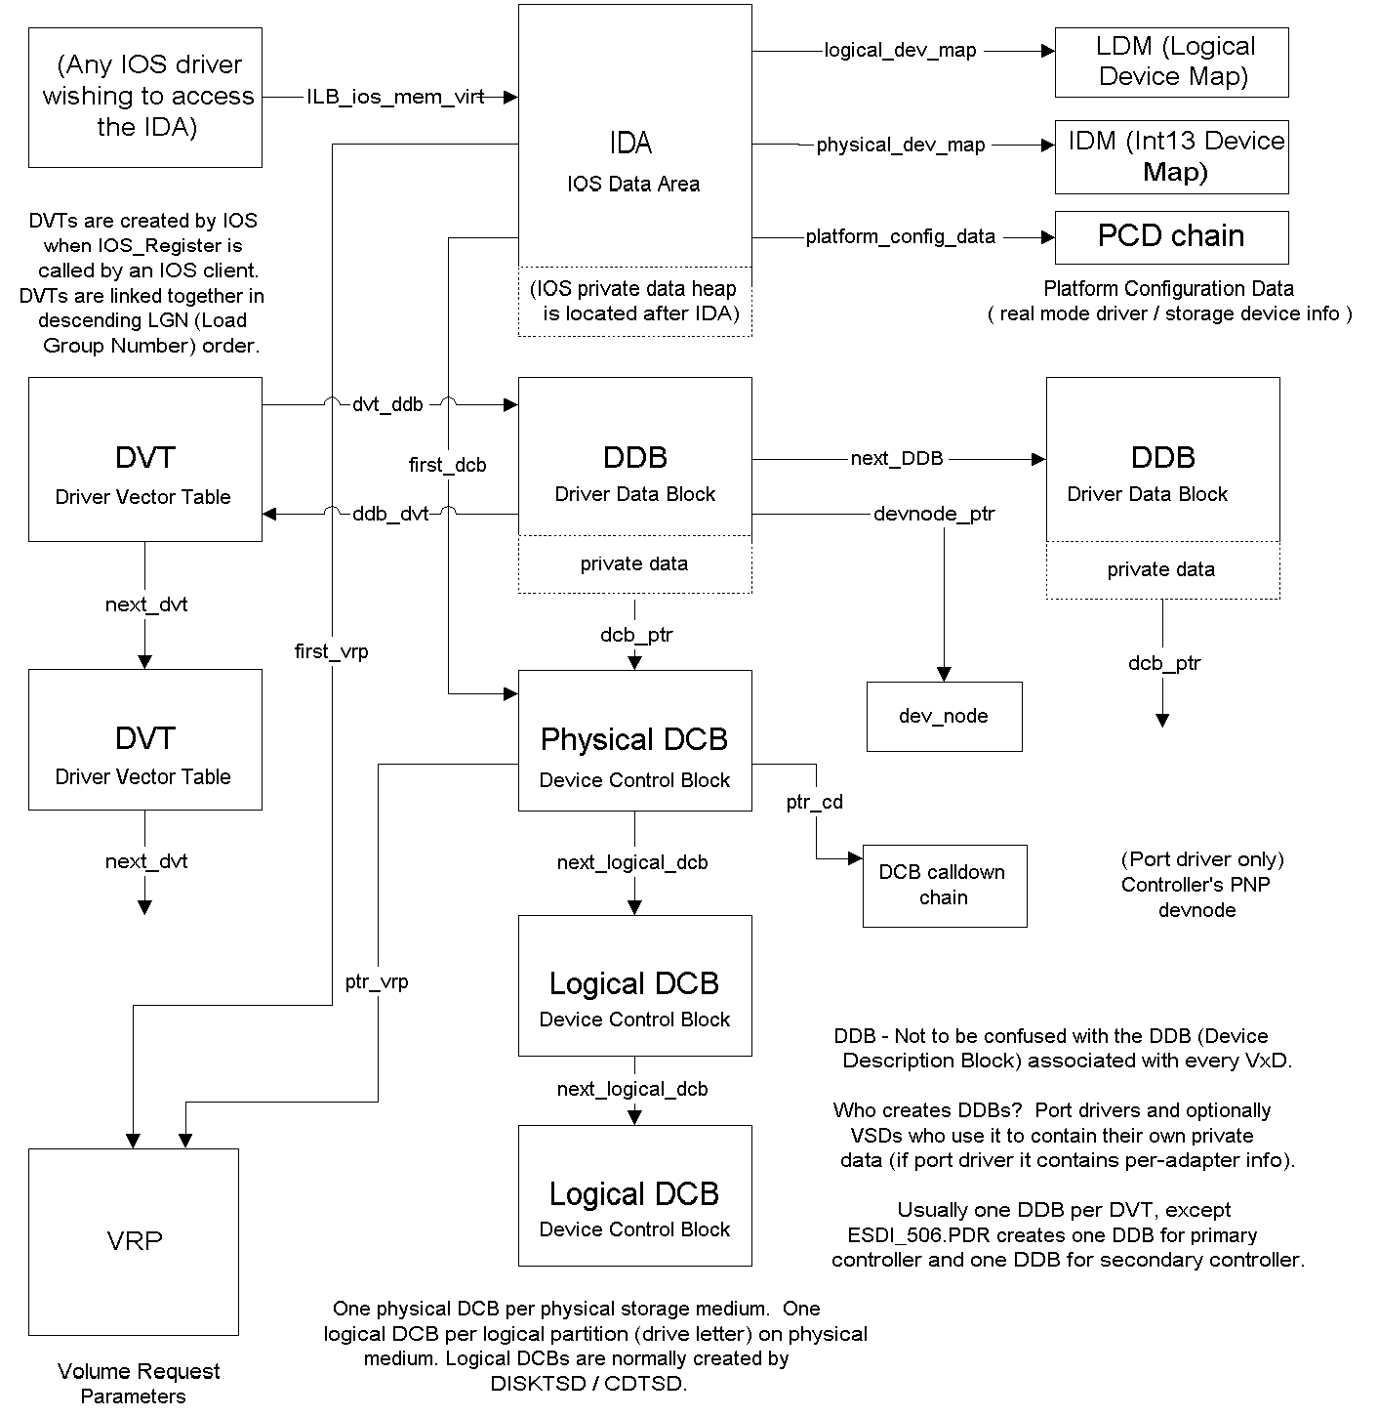

IDA (IOS Data Area)
Use .IDIDA from debugger for list (using the debug version of IOS.VXD)
Offset | Element | Comments
08 | ULONG IDA_ios_mem_phys | Physical address of IOS memory pool
10 | ULONG IDA_ios_timer | Counter - ticks every 250 milliseconds
20 | CHAR IDA_esdi_p_in_use | Non-zero = ESDI_506 has claimed the primary esdi i/o addresses (1f0 thru 1f7, 3f6 and 3f7) and irq (irq 14).
21 | CHAR IDA_esdi_s_in_use | Non-zero = ESDI_506 has claimed the secondary esdi i/o addresses(170 thru 177, 376 and 377) and irq (irq 15).
22 | CHAR IDA_Num_Floppies | No. of floppies in the system as determined by the real-mode init portion of IOS.VXD.
24 | USHORT IDA_platform | Platform (machine type) code.  #define IS_ISA 0x0001 // platform is isa  #define IS_EISA 0x0002 // platform is eisa  #define IS_MCA 0x0004 // platform is microchannel  #define IS_FAMILY3 0x0008 // platform is Family 3
28 | ULONG IDA_flags | Various state flags, see below for value definitions  IDAF_BOOT_COMPLETE 0x0001 // boot complete  IDAF_REAL_MODE_ONLY 0x0002 // no prot mode port  drivers may load  IDAF_BIG_MEMORY 0x0040 // >16MB system memory.  IDAF_PUNT_CDS 0x0800 // force CD access through  real mode (unsafe CD  driver found)  IDAF_MSCDEX_PRESENT 0x1000 // indicates MSCDEX in the  system  IDAF_DOS_PAGER 0x2000 // system is paging  through DOS  IDAF_SHUTDOWN 0x4000 // system is shutting down
6C | USHORT IDA_rm_irq | Bitmap of unrecognized real mode drivers' IRQs. Used to identify which IRQs cannot be used by protected mode drivers.
2C | PVOID IDA_platform_config_data | Pointer to PCD chain (containing structures PCD_fixed_disk, and PCD_floppy_disk obtained prior to switch to protected mode) as computed in the real-mode init portion of IOS.VXD. See Listing 1 for structure.
30 | PVOID IDA_first_dcb | Pointer to first DCB.
34 | PVOID IDA_logical_dev_map | Pointer to array of LDM structures (see Listing 2). Logical device map for real-mode devices.
38 | PVOID IDA_physical_dev_map | Pointer to struct IDM array Int13 disk map. Structure used to audit and reconcile boot record vs. drive letter when assigning drive letters during IOS conversion from real mode to protected mode drivers. First built during real-mode IOS init phase. Contains list of these structures:  typedef struct IDM {  UCHAR IDM_int13_number; // int 13 unit; FFh if end  of table  ULONG IDM_signature; // signature from boot  record  ULONG IDM_checksum; // checksum of boot record  USHORT IDM_flags; // bit flags; 0x1=sig is  checksum method,  0x2=has been claimed by  protected mode driver  } IDM
3C | PVOID IDA_rmm_phys_dcb | Pointer to the RMM (Real Mode Mapper for handling real-mode drivers) DCB if there is one.
40 | PVOID IDA_first_vrp | Pointer to first Volume Request Parameters structure (VRPs are chained together via VRP_next_vrp. See VRP.H.
44 | ULONG IDA_drive_letter_map | Logical drive bitmap for assigning logical disk numbers
48 | ULONG IDA_cdrom_letter_map | Logical drive bitmap for cd-rom devices
4C | ULONG IDA_rmd_ptr | Flat pointer to start of INT 2fh startup chain (Pointer to RMD list head), obtained using INT 2fh function 16h, subfunction 90h
50 | ULONG IDA_aspi_cam_rmds | Start of ASPI/CAM RMD's
54 | ULONG IDA_big_mem_buf_virt | Big memory buffer ptrs
58 | ULONG IDA_big_mem_buf_phys | Physical address of big memory buffer
5C | ULONG IDA_big_mem_buf_size | Size of big memory buffer
60 | ULONG IDA_ios_mem_pool_size | Size of IOS local heap - size of IDA structure (memory available for IOS layer driver or port driver memory requests).
Miscellaneous internal IOS static info (also displayed using .IDIDA)
Offset | Element | Comments
- | DCB * logical_drive_table[26] | This table maps the logical drive letters to their corresponding DCB.
- | DCB * physical_drive_table[24] | This table maps pointers to the DCBs corresponding to INT13 non-diskette physical disk storage unit numbers (starting with BIOS unit 0x80)
- | DCB * physical_floppy_table[8] | This table maps pointers to the DCBs corresponding to INT13 diskette physical disk storage unit numbers (starting with BIOS unit 0x00)
- | void * IOSPanicHead | panic buffer list head; used when IOS is blocked from being able to allocate memory from heap.
- | IOSInitFlags | Assorted these flags, mostly used internally by IOS to manage the handling of real mode ASPI and CAM drivers. Bit 0x400 indicates IOS has completed its initialization (IOS_Init_Complete).
- | IOS_Int13_Device_Chain | This is a linked list consisting of the DCB_bdd portion of each DCB supporting INT13. The DCB_bdd’s are linked using the DCB_BDD_Next field.
- | Void * MemSem | Wait_semaphore() semaphore handle data used by the IOS memory manager. Blocks while waiting for some other IOS client to free some memory up. See also MemBlockers.
- | BYTE MemBlockers | Count of threads awaiting memory allocation via the MemSem semaphore.
- | Void * SemTabSem | Semaphore, initially allocated with 8 credits. Blocks if more than 8 threads attempt to go through IOS. If doesn’t block, then one of the SemTab[] semaphores are used to accommodate the synchronous mechanism.
- | Void * SemTab[8] | 8 semaphores are allocated to accommodate synchronous commands. The byte in SemTabInd indicates free/busy semaphores in SemTab.
- | BYTE SemTabInd | Bit map indicating which SemTab[] semaphores are in use. Bit clear (0) indicates semaphore is in use.
- | DCB * inquiry_dcb | Pointer to the inquiry DCB used by IOS during AEP_DEVICE_INQUIRY phase of layer driver initialization. Used for testing for the existence of physical devices attached to port drivers. NOTE: This DCB is deallocated from memory after IOS completes initialization.

DVT (Driver Vector Table)
(One per driver or VSD; these are chained together in descending LGN number)
Use .IDDVT from debugger for list (using the debug version of IOS.VXD)
Offset | Element | Comments
02 | ULONG DVT_next_dvt | Pointer to next DVT
06 | USHORT DVT_device_cnt | Count of devices (DCBs) added/accepted.
08 | PVOID DVT_aer | Driver's Async Event Routine (entry point for IOS AEP_… calls)
0C | ULONG DVT_ddb | First DDB for this DVT
10 | ULONG DVT_ddb_init | First DDB for this DVT when first created during initialization (used by IOS to manage DDBs for all DVTs)
14 | CHAR DVT_ascii_name[DVT_NAME_LEN] | Name of driver including extension, e.g. esdi_506.pdr
24 | CHAR DVT_create_date[DVT_DATE_LEN] | (optional) date of creation
2C | CHAR DVT_create_time[DVT_TIME_LEN] | (optional) time of creation
34 | CHAR DVT_rev_level[DVT_REV_LEN] | (optional) revision level of driver
38 | ULONG DVT_feature_code | Feature code See Listing 3.
3C | USHORT DVT_if_requirements | Reserved. Not currently used.
3E | BYTE DVT_bus_type | I/O bus type  DVT_BT_ESDI 0x00 // ESDI or ESDI emulator  DVT_BT_SCSI 0x01 // SCSI or SCSI emulator  DVT_BT_FLOPPY 0x02 // FLOPPY  DVT_BT_SMART 0x03 // smart device  DVT_BT_ABIOS 0x04 // ABIOS or ABIOS emulator
3F | ULONG DVT_reference_data | Reference data passed via DRP_reference_data when this driver registers using IOS_Register.
43 | CHAR DVT_first_drive | Reserved. Not currently used.
44 | CHAR DVT_current_lgn | Load group number assigned to this driver.
45 | ULONG DVT_LoadHandle | Contains the Vxd's load handle (from VXDLDR_LoadDevice) if we loaded the driver else 0
49 | CHAR DVT_scsi_max_target | SCSI: max target reported by SCSI (AEP_bi_i_max_target / MaximumNumberOfTargets)
4A | CHAR DVT_scsi_max_lun | SCSI: max LUN supported for SCSI (set to 0x7 by SCSIPORT)
4B | PVOID DVT_entry_point | SCSI: _PELDR_GetEntryPoint’s entry point into NT SCSI miniport driver
4F | UCHAR DVT_init_count | Number of successful AEP_INITIALIZE calls (port drivers only). If zero upon init completion, IOS will deregister this port driver.

DDB (Driver Data Block)
Offset | Element | Comments
00 | ULONG DDB_phys_addr | Physical address of DDB
04 | ULONG DDB_Next_DDB | Next DDB on dvt_DDB chain
08 | ULONG DDB_Next_DDB_init | Next DDB on dvt_DDB_init chain (used by IOS to manage DDBs for all DVTs)
0C | ULONG DDB_dcb_ptr | Pointer to first DCB owned by this DDB
10 | UCHAR DDB_number_buses | Number of buses supported by the adapter
11 | UCHAR DDB_ios_flags | IOS private flags - read only for non-IOS
12 | USHORT DDB_sig | DWORD padding (also DDB signature for asserting)
14 | PDVT DDB_dvt | Pointer to this DDB's DVT
18 | DEVNODE DDB_devnode_ptr | Pointer to Plug & Play device node for device
1C | PDDB_ACPI_BLOCK DDB_pAcpiBlock | (Win98 onwards. IDE ACPI support. NULL if IDE isn’t behind ACPI)

_DDB_ACPI_BLOCK
(pointed to by DDB_pAcpiBlock above)
Offset | Element | Comments
00 | TIMINGMODEEX DDB_ACPI_TimingMode | Future use (all fields in debug dump that begin with “tm_”
14 | BYTE DDB_ACPI_bPowerState | Current ACPI Power State (e. g. CM_POWERSTATE_D0)
15 | BYTE DDB_ACPI_bIdeLevel | IDE compliance level
16 | WORD DDB_ACPI_wSig | Signature (0x5043)
 | (Each of the following arrays contain two elements, to accommodate both primary and secondary IDE controller)
18 | ULONG DDB_ACPI_hTaskFile[2] | Future use
20 | ULONG DDB_ACPI_dwEidLength[2] | Length of ATA EID structure
28 | ULONG DDB_ACPI_dwEid[2] | Future use
30 | ULONG DDB_ACPI_dwTaskFileLength[2] | Future use
38 | ULONG DDB_ACPI_dwTaskFile[2] | Future use

DCB (Device Control Block)

Use .IDDCB from debugger for list (using the debug version of IOS.VXD).

DCB_common area
Offset | Element | Comments
00 | ULONG DCB_physical_dcb | Pointer to physical device DCB (can be self)
04 | ULONG DCB_expansion_length | Total length of IOP extension filled in by IOS (excludes IOP size)
08 | PVOID DCB_ptr_cd | Pointer to calldown list (see structure _DCB_cd_entry below). This list is used to initialize new IOP packets, each of which point to calldown entries via IOP_calldown_ptr.
0C | ULONG DCB_next_dcb | Link to next DCB. Forms a global DCB chain (containing all DCBs in system)
10 | ULONG DCB_next_logical_dcb | Pointer to next logical DCB associated with this device
14 | BYTE DCB_drive_lttr_equiv | Drive number (A: = 0, etc.) set up by ISP_ASSOCIATE_DCB and TSDs during logical device associate processing.
15 | BYTE DCB_unit_number | Either physical drive number(sequential INT13 drive number or'd with 80h) or unit number within TSD. Set up for disk physical DCBs. Set up by DISKTSD for disk logical DCB's. Set up by CDTSD for cdrom physical DCB's.
16 | USHORT DCB_TSD_Flags | Flags for TSD. See DCB.H
18 | ULONG DCB_vrp_ptr | Pointer to VRP for this DCB
1C | ULONG DCB_dmd_flags | Demand bits of the topmost layer
20 | ULONG DCB_device_flags | Was BDD_Flags
24 | ULONG DCB_device_flags2 | Second set of general purpose flags
28 | ULONG DCB_Partition_Start | Partition start sector
2C | ULONG DCB_track_table_ptr | Pointer for the track table buffer for ioctls
30 | ULONG DCB_bds_ptr | DOS BDS corresp. to this DCB (logical DCB's only)
34 | ULONG DCB_Reserved1 | Reserved
38 | ULONG DCB_pEID | (IDE device) Pointer to EID structure obtained from IDE device.
3C | BYTE DCB_apparent_blk_shift | Log to base 2 of apparent_blk_size
3D | BYTE DCB_partition_type | Partition type
3E | USHORT DCB_sig | Padding and signature
40 | BYTE DCB_device_type | Device Type (see DCB.H)
41 | ULONG DCB_Exclusive_VM | Handle for exclusive access to this device
45 | UCHAR DCB_disk_bpb_flags | BPB flags
46 | UCHAR DCB_cAssoc | Count of logical drives associated with this logical DCB
47 | UCHAR DCB_Sstor_Host | This field indicates a SuperStor host volume
48 | USHORT DCB_user_drvlet | Contains the UserDriveLetterAssignment settings from registry, else 0xFF
4A | USHORT DCB_Reserved3 | Reserved
4C | BYTE DCB_fACPI | (Win98) Indicates we are on ACPI subtree
4D | BYTE DCB_fSpinDownIssued | (Win98) Indicates a spindown has been issued
4E | BYTE DCB_bPowerState | (Win98) Current CM_POWERSTATE_Dn
4F | BYTE DCB_bEidLength | (Win98) for ACPI _STM – always 1 to indicate 1 sector (512 bytes).
(DCB ends here if it is a logical (non-physical) DCB)

DCB physical data extension
Offset | Element | Comments
50 | ULONG DCB_max_xfer_len | Maximum transfer length supported by the driver/hardware
54 | ULONG DCB_actual_sector_cnt [2] | Number of sectors as seen below the TSD.
5C | ULONG DCB_actual_blk_size | Actual block size of the device as seen below the TSD.
60 | ULONG DCB_actual_head_cnt | Number of heads as seen below the TSD.
64 | ULONG DCB_actual_cyl_cnt | Number of cylinders as seen below the TSD
68 | ULONG DCB_actual_spt | Number of sectors per track as seen below the TSD.
6C | PVOID DCB_next_ddb_dcb | Link to next physical DCB, if more than one physical DCB is associated with a DDB.
70 | PVOID DCB_dev_node | Pointer to Plug & Play device node for this device
74 | BYTE DCB_bus_type | Type of bus (see DCB.H).
75 | BYTE DCB_bus_number | Channel (cable) within adapter
76 | UCHAR DCB_queue_freeze | Queue freeze depth counter. If nonzero indicates frozen. Tested but not set by IOS services’ Dequeue_Iop() (Unless there are BYPASS_QUEUE IOP’s, Dequeue_IOP is disabled).
77 | UCHAR DCB_max_sg_elements | Max # of logical and/or physical s/g elements. Set initially by port, but may be MORE RESTRICTIVELY updated by other layers
78 | UCHAR DCB_io_pend_count | Indicates number of requests pending for this DCB (VOLUME TRACKING LAYER USE ONLY)
79 | UCHAR DCB_lock_count | Depth counter for LOCK MEDIA commands (VOLUME TRACKING LAYER USE ONLY)
7A | USHORT DCB_SCSI_VSD_FLAGS | Flags for SRB builder (DISKVSD)
7C | BYTE DCB_scsi_target_id | SCSI target ID
7D | BYTE DCB_scsi_lun | SCSI logical unit number
7E | BYTE DCB_scsi_hba | Host Bus Adapter number relative to port driver
7F | BYTE DCB_max_sense_data_len | Maximum Sense Data length
80 | USHORT DCB_srb_ext_size | Miniport SRB extension length (HwInitializationData->SrbExtensionSize; per-request storage required by the miniport driver)
82 | BYTE DCB_inquiry_flags[8] | Inquiry buffer; contains results of Device Inquiry issued to the hardware. The first byte contains the DCB_type_… reported by the hardware (see DCB.H)
8A | BYTE DCB_vendor_id[8] | Vendor ID string
92 | BYTE DCB_product_id[16] | Product ID string
A2 | BYTE DCB_rev_level[4] | Product revision level
A6 | BYTE DCB_port_name[8] | Name of driver, such as ESDI_506.PDR
AE | UCHAR DCB_current_unit | Used to emulate multiple logical devices with a single physical device, e.g. the same physical floppy drive can be drive A: or B:
AF | ULONG DCB_blocked_iop | Pointer to requests for an inactive volume (VOLUME TRACKING LAYER USE ONLY)
B3 | ULONG DCB_vol_unlock_timer | Unlock timer handle
B7 | UCHAR DCB_access_timer | Used to measure time between accesses
B8 | UCHAR DCB_Vol_Flags | Flags for Volume Tracking volume tracking use only
B9 | BYTE DCB_q_algo | Queuing algorithm index – 0=FIFO, 1=SORTED
BA | BYTE DCB_unit_on_ctl | Relative device number on ctlr (0-based)
BB | ULONG DCB_Port_Specific | Bytes for PORT DRIVER use
BF | ULONG DCB_spindown_timer | Timer for drive spin down

Extension for INT13h drives (BDD) blockdev compatibility. The following fields directly correlate with the BLOCKDEV structure BlockDev_Device_Descriptor used in Windows 3.1x BLOCKDEV (fastdisk) drivers.
Offset | Element | Comments
C3 | ULONG DCB_BDD_Next | (aka BDD_Next) Chaining pointer to next BDD
C7 | BYTE DCB_BDD_BD_Major_Version | (aka BDD_Major_Version)
C8 | BYTE DCB_BDD_BD_Minor_Version | (aka BDD_Minor_Version)
C9 | BYTE DCB_BDD_Device_SubType | (aka BDD_Device_Type)
CA | BYTE DCB_BDD_Int_13h_Number | (aka BDD_Int_13h_Number)
CB | ULONG DCB_BDD_flags | (aka BDD_Flags)
CF | ULONG DCB_BDD_Name_Ptr | (aka BDD_Name_Ptr)
D3 | ULONG DCB_apparent_sector_cnt[2] | (aka BDD_Max_Sector[2]) No. of sectors as seen by TSD and above
DB | ULONG DCB_apparent_blk_size | (aka BDD_Sector_Size) block size of dev. as seen by TSD and above
DF | ULONG DCB_apparent_head_cnt | (aka BDD_Num_Heads) No. of heads as seen by TSD and above
E3 | ULONG DCB_apparent_cyl_cnt | (aka BDD_Num_Cylinders) No. of cyls as seen by TSD and above
E7 | ULONG DCB_apparent_spt | (aka BDD_Num_Sec_Per_Track) No. of secs/trk as seen by TSD and above
EB | ULONG DCB_BDD_Sync_Cmd_Proc | (aka BDD_Sync_Cmd_Proc)
EF | ULONG DCB_BDD_Command_Proc | (aka BDD_Command_Proc)
F3 | ULONG DCB_BDD_Hw_Int_Proc | (aka BDD_Hw_Int_Proc) Hardware interrupt procedure, <0> to indicate none used
 | (End of BlockDev_Device_Descriptor)
F7 | ULONG DCB_BDP_Cmd_Queue_Ascending | Ptrs to queued IOP’s. Each IOP uses its IOR_next field as a chaining pointer.
FB | ULONG DCB_BDP_Cmd_Queue_Descending | Ptrs to queued IOP’s. Each IOP uses its IOR_next field as a chaining pointer.
FF | ULONG DCB_BDP_Current_Flags
103 | ULONG DCB_BDP_Int13_Param_Ptr
107 | ULONG DCB_BDP_Current_Command
10B | ULONG DCB_BDP_Current_Position[2] | Used to remember prior sector number (used by enqueue_iop to determine whether to queue ascending or descending)
113 | ULONG DCB_BDP_Reserved[5]
127 | ULONG DCB_fastdisk_bdd | Set for DCBs created when a fastdisk (Win3.1 block driver) registers with the blockdev BDD for it else 0

DCB_CDROM data extension
Offset | Element | Comments
12B | ULONG DCB_cdrom_Partition_Start | Partition start sector
12F | ULONG DCB_cdrom_Partition_End | Partition end sector
133 | UCHAR DCB_cd_ls_ft | First track number in the last session
134 | ULONG DCB_TOC[202] | CDROM Table of Contents buffer
45C | ULONG DCB_cd_mode_sense_buf[20/4+1] | CDROM mode sense buffer
474 | UCHAR DCB_cd_first_session | Index number of first session
475 | UCHAR DCB_cd_last_session | Index of last session on disc
476 | ULONG DCB_play_resume_start | Re-start address when paused (LBA)
47A | ULONG DCB_play_resume_stop | End of re-started play (LBA)
47E | ULONG DCB_play_status | Last command play status
482 | ULONG DCB_cd_device_flags | Flags indicating the audio support capabilities of the device
486 | UCHAR DCB_cd_fs_lt | Last track in the first session
487 | UCHAR DCB_cd_bobbit_pt | Indicates the track where a CDPLUS disc is terminated to prevent data tracks from showing up in the table of contents
488 | ULONG DCB_cd_fs_lo | Lead out address of first session
48C | ULONG DCB_cd_last_session_start | LBA start address of data area in the last session on a multi-session disc
490 | ULONG DCB_cd_current_block_size | Current block size selected by the mode command
494 | UCHAR DCB_cd_vol_map[8] | Current volume / channel mapping
4BC | ULONG DCB_cd_current_command | Current command
4A0 | ULONG DCB_cd_queue_head | Head of current command queue
4A4 | ULONG DCB_cd_reserved | Reserved

_DCB_disk extension
Offset | Element | Comments
12F | USHORT DCB_write_precomp | Write Precompensation
131 | ULONG DCB_disk_tsd_private | Private area for TSD. used to store b: BDS ptr for single flp

_DCB_cd_entry
(Calldown entry contained in calldown chain pointed to by DCB_ptr_cd)
Offset | Element | Comments
00 | PVOID DCB_cd_io_address | Address of an IOS driver’s AER request routine
04 | ULONG DCB_cd_flags | Demand bits - as defined below
08 | ULONG DCB_cd_ddb | Driver’s DDB pointer
0C | ULONG DCB_cd_next | Pointer to next calldown entry
10 | USHORT DCB_cd_expan_off | Offset of expansion area used by the request routine
12 | UCHAR DCB_cd_layer_flags | Flags for layer's use
13 | UCHAR DCB_cd_lgn | Load Group number (IOS layer driver order)

IOP (Input/Output Packet)
Offset | Element | Comments
00 | ULONG IOP_physical | Physical address of IOP.
04 | ULONG IOP_physical_dcb | Pointer to physical DCB. Filled in by IOS_SendCommand or ILB_Internal_Request
08 | ULONG IOP_original_dcb | Pointer to DCB designated by IOR. Filled in by IOS_SendCommand (address of logical DCB)
0C | USHORT IOP_timer | Current timeout value. Filled in by IOS_SendCommand. Default value = 15 (7.5 seconds)
0E | USHORT IOP_timer_orig | rcb original timeout value. Filled in by IOS_SendCommand. Default value = 15 (7.5 seconds)
10 | ULONG IOP_calldown_ptr | Pointer to next calldown routine (structure type DCB cd_entry) Filled in by IOS_SendCommand.
14 | ULONG IOP_callback_ptr | Pointer to current callback address.
18 | ULONG IOP_voltrk_private | For use by volume tracking.
1C | ULONG IOP_Thread_Handle | Contains the handle of the thread in whose context this IO originated. This is initialized in IOS_SendCommand. Not used if called via ILB_Internal_Request.
20 | ULONG IOP_srb | Used by SCSI'izers (or by SCSI Passthrough requests) to pass SRB pointer to next layer. Valid if (IOR_flags & IORF_SRB_VALID) is set
24 | ULONG IOP_reserved[2] | Reserved for future use - must be zero.
2C | IOP_callback_entry IOP_callback_table[IOP_CALLBACK_TABLE_DEPTH] | The mechanism to allow layer drivers to be called on the way back up, after the port driver has completed processing the IOP. The layer driver requests this event by adding itself to the callback table, when it is processing the IOP, before it gets to the port driver. See IOP_callback_entry below.
5C | BYTE IOP_format_head | Fields for low level format
5D | BYTE IOP_format_xfer_rate
5E | USHORT IOP_format_track
60 | ULONG IOP_format_num_sectors
 | IOR IOP_ior | I/O request descriptor (attached contiguously to IOP)

IOR (Input/Output Request Block)
Offset | Element | Comments
64/00 | ULONG IOR_next | Client link for BCB's (for IORF_VERSION_002)
68/04 | USHORT IOR_func | Function to be performed - see defines below.
6A/06 | USHORT IOR_status | Request status - see IOR.H
6C/08 | ULONG IOR_flags | Request control flags – see IOR.H
70/0C | CMDCPLT IOR_callback | Address to call request back to if IORF_SYNC_COMMAND is not set (used in internal IOS_SendCommand routine).
74/10 | ULONG IOR_start_addr[2] | Volume relative starting addr. if IORF_LOGICAL_START_SECTOR is set. physical if not set.
7C/18 | ULONG IOR_xfer_count | Number of sectors to process if IORF_CHAR_COMMAND is not set, or # of bytes if it is set. MUST be set to zero if no data transfer. Must be less than 65536 if CD-ROM.
80/1C | ULONG IOR_buffer_ptr | BlockDev client buffer pointer. Contains pointer to data buffer or to null terminated list of linear SGDs depending on IORF_SCATTER_GATHER. Undefined if no data transfer.
84/20 | ULONG IOR_private_client | BlockDev/IOS client reserved.
88/24 | ULONG IOR_private_IOS | Reserved space for IOS.
8C/28 | ULONG IOR_private_port | Private area for port driver.
90/2C | union urequestor_usage _ureq | Requestor usage area, also used for IOCTL's. SCSIPORT uses this to point to SRB.
A4/40 | ULONG IOR_req_req_handle | Requestor provided request handle. Often is a pointer to this IOR or its containing IOP. Pushed on the stack by IOS before IOR_callback is called
A8/44 | ULONG IOR_req_vol_handle | Requestor provided media handle designating the media to perform the function on (VRP).
AC/48 | ULONG IOR_sgd_lin_phys | Pointer to first physical SGD, as contrasted with IOR_buffer_ptr, which points to the logical SGDs. This is either a linear or phys address, depending on the needs of the drivers, as indicated via the DCB demand bits.
B0/4C | UCHAR IOR_num_sgds | Number of physical SGDs pointed to by IOR_sgd_lin_phys
B1/4D | UCHAR IOR_vol_designtr | Numeric representation of the drive letter designating the volume to perform the function on (c: = 2). Set this to DCB_unit_number.
B2/4E | USHORT IOR_ios_private_1 | Reserved by IOS to audit alignment. Currently used only within the ILB_io_criteria_rtn.
B4/50 | ULONG IOR_reserved_2[2] | Reserved for internal use

IOP_callback_entry
Offset | Element | Comments
00 | ULONG IOP_CB_address | Call back address
04 | ULONG IOP_CB_ref_data | Pointer to callback reference data

SRB (SCSI_REQUEST_BLOCK)
Offset | Element | Comments
0 | USHORT Length | IN: Size SCSI_REQUEST_BLOCK
2 | UCHAR Function | IN: Function (See )
3 | UCHAR SrbStatus | OUT: Status from HBA
4 | UCHAR ScsiStatus | OUT: Status from HBA
5 | UCHAR PathId | IN: Set to DCB_bus_number (geometry)
6 | UCHAR TargetId | IN: Set to DCB_scsi_target_id
7 | UCHAR Lun | IN: Set to DCB_scsi_lun
8 | UCHAR QueueTag | IN: 0. Used by SCSIPORT to enqueue the SRB on the adapter's input queue. Also see MultipleRequestPerLu in HW_INITIALIZATION_DATA structure.
9 | UCHAR QueueAction | IN: 0 (Not used in SCSIPORT)
a | UCHAR CdbLength | IN: Length of CDB e.g. 6 for Inquiry
b | UCHAR SenseInfoBufferLength | IN: Length of SenseInfoBuffer. Postcall: miniport driver updates this field if it supports auto sense request (transfers sense-request info).
c | ULONG SrbFlags | IN; e.g. SRB_FLAGS_DATA_IN + SRB_FLAGS_DISABLE_DISCONNECT
10 | ULONG DataTransferLength | IN:Size of DataBuffer, e.g. SIZE_OF_INQUIRYDATA.  OUT: miniport driver updates this field if an under-run or over-run occurs. Caution: this field, combined with DataBuffer is used by Windows 95 ScsiPort(xxx)Buffer(xxx) (SGD emulation) routines when searching for the SRB corresponding to the memory buffer address desired. In such cases, if this SRB is being accessed by the miniport driver, never modify these fields.
14 | ULONG TimeOutValue | IN: Must set this pre-request, if SCSI PASSTHROUGH. SCSIPORT puts this into IOP_timer and IOP_timer_orig (500ms intervals)
18 | PVOID DataBuffer | IN: Point to memory created using the ILB_Service_rtn() ISP_Alloc_Mem, e.g. SIZE_OF_INQUIRYDATA etc. SCSIPORT sets this to the value in IOP_ior.buffer_ptr, if SRB_flags indicate data transfer in or out.
1c | PVOID SenseInfoBuffer | IN: Pointer to Sense info buffer; which is typically located just past our SrbExtension. Make large enough to accommodate worst-case Sense data from drive. Set to null to disable autosense.
20 | struct _SCSI_REQUEST_BLOCK *NextSrb | IN: Set to 0. SCSIPORT uses this field to link the enqueued SRB’s in a chain (see QueueTag above)
24 | PVOID OriginalRequest | IN: 0. Not used by SCSIPORT.
28 | PVOID SrbExtension | IN: Pointer to extension area (just past this SRB, and the _PORT_SRB extension). Length of this extension area is DCB_srb_ext_size. Setup by ScsiPortInitialize() to supply miniport requested/defined per-request state information storage.
2c | ULONG QueueSortKey | Used in SCSIPORT as a temporary to hold a pointer to an APE structure if paging drive is having problems and drive retries are required.
30 | UCHAR Cdb[16] | IN: Contains desired CDB to issue to HBA. Actual command length is CdbLength. If communicating with an ATAPI device (through ESDI_506.PDR), length can be set to (a max of) 12, even if an actual command uses fewer bytes. If communicating with a SCSI device, the length must correspond to the expected length of the command.

_PORT_SRB
(Windows 9x Miniport SRB extension)
Offset | Element | Comments
00 | SCSI_REQUEST_BLOCK BaseSrb | _PORT_SRB IS AN EXTENSION OF SCSI_REQUEST_BLOCK; not present under Windows NT / Windows 2000
40 | PVOID SrbIopPointer | IN: Pointer to the IOP. This is a means for the SCSI miniport driver to gain access to the IOP (not compatible with the NT SCSI miniport model)
44 | SCSI_REQUEST_BLOCK *SrbNextSrb | This pointer chains pending SRBs together. Used by SCSIPORT.PDR to manage SRBs.
48 | SCSI_REQUEST_BLOCK *SrbNextActiveSrb | IN: Allows SCSIPORT to keep a list of all active SRBs (SRBs that have been submitted to a miniport and are still under its control).
4C | UCHAR SrbRetryCount | Internal variable to keep track of hardware retries. Used by DISKVSD / CDVSD.
4D | UCHAR Filler[3]

Appendix 3 - IOS Registration Flowchart

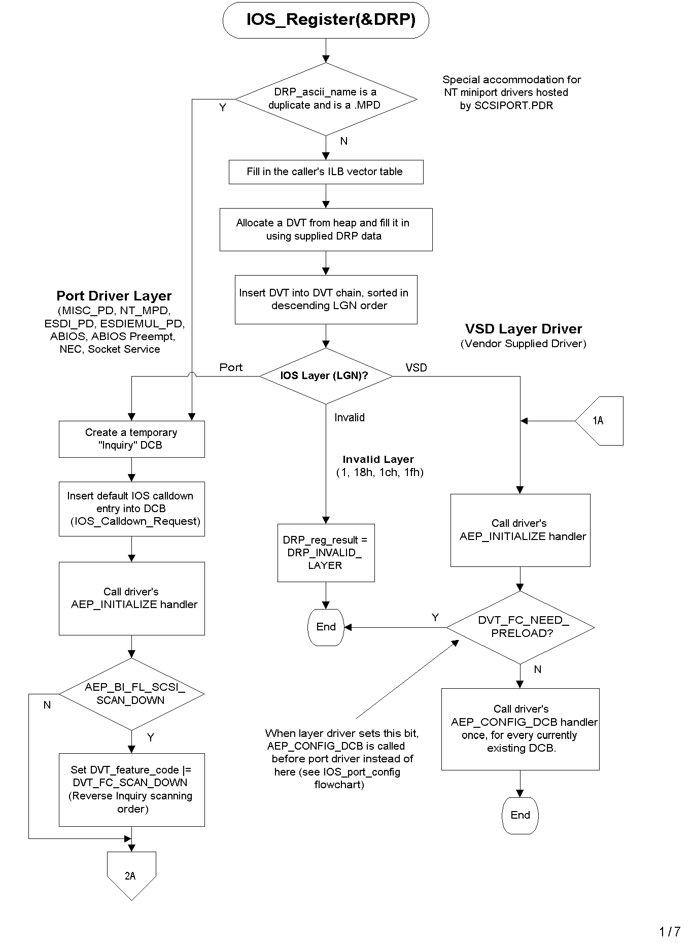
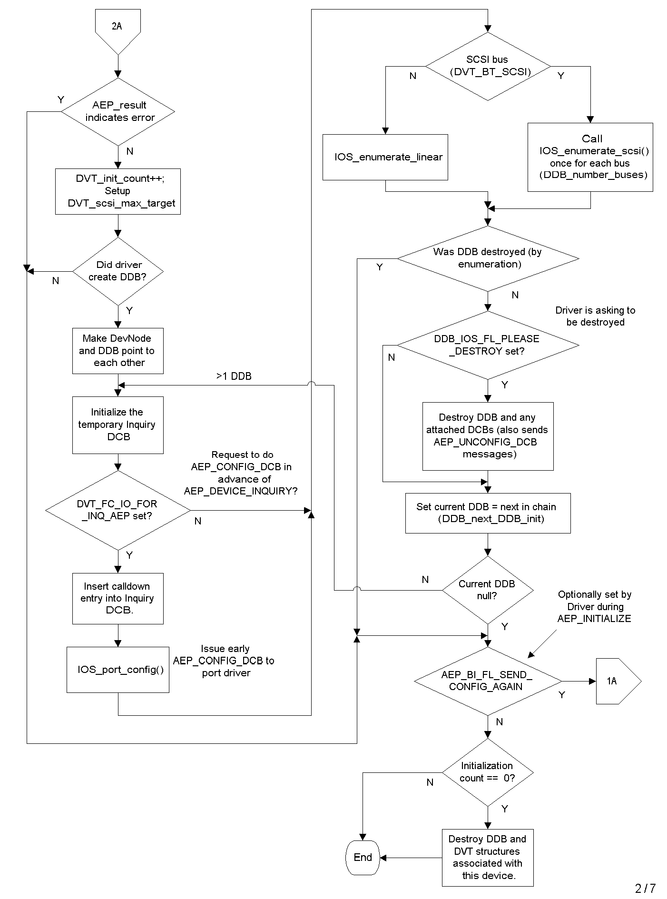
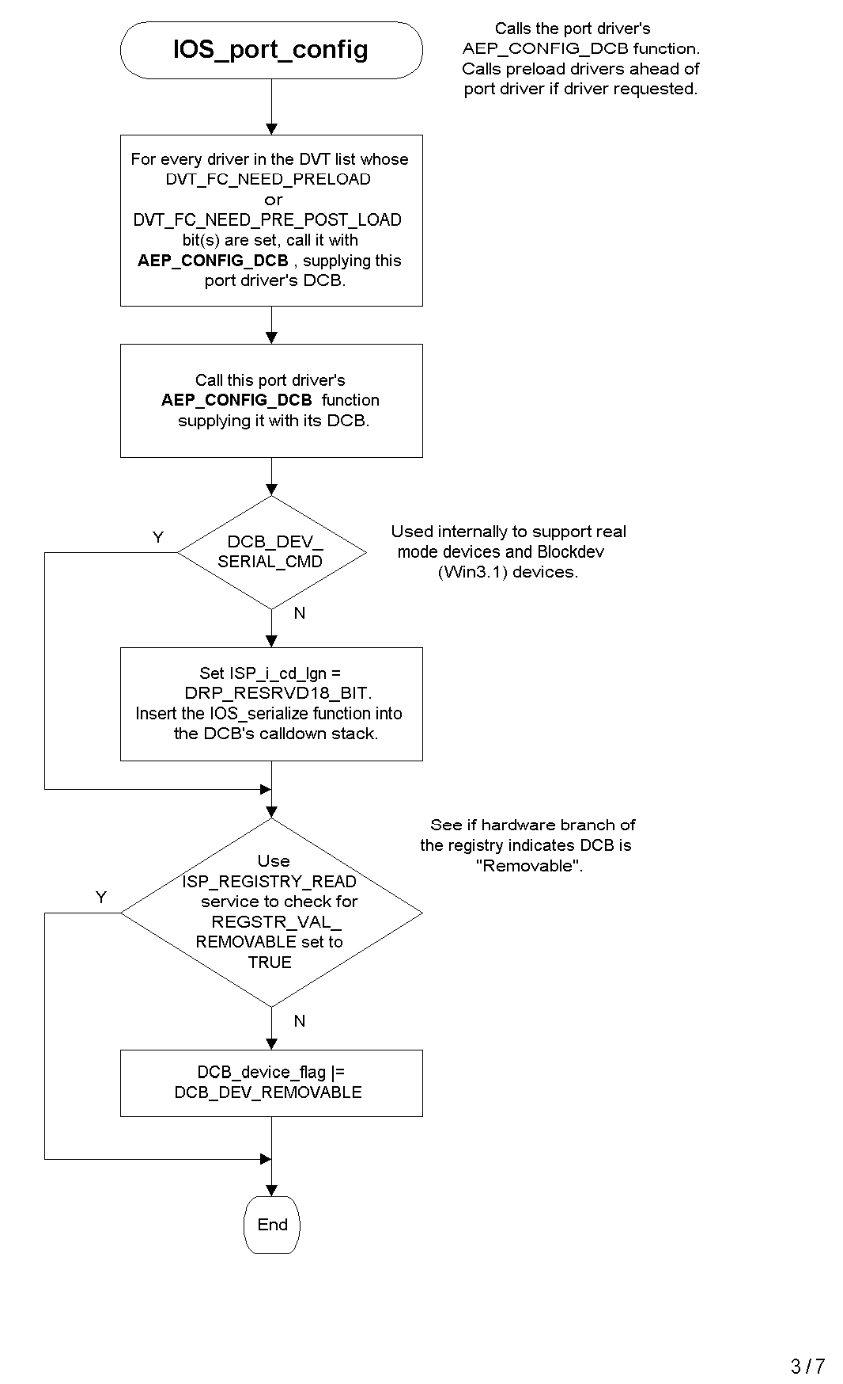
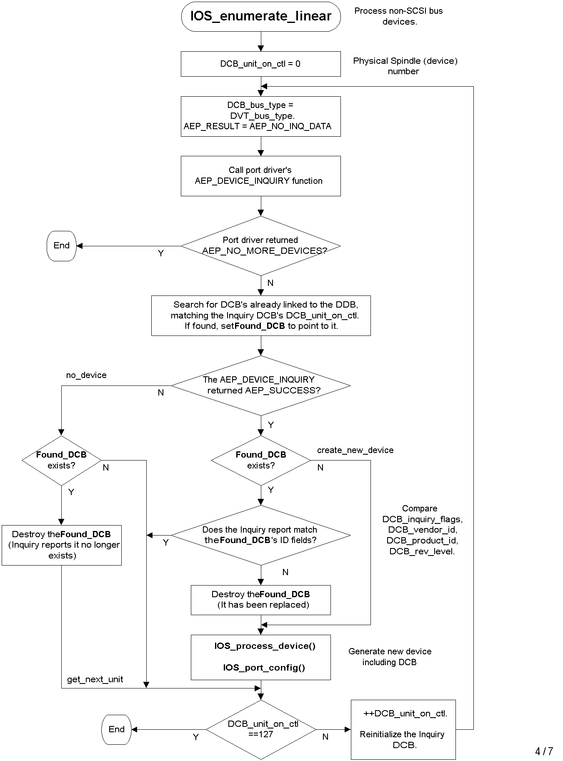
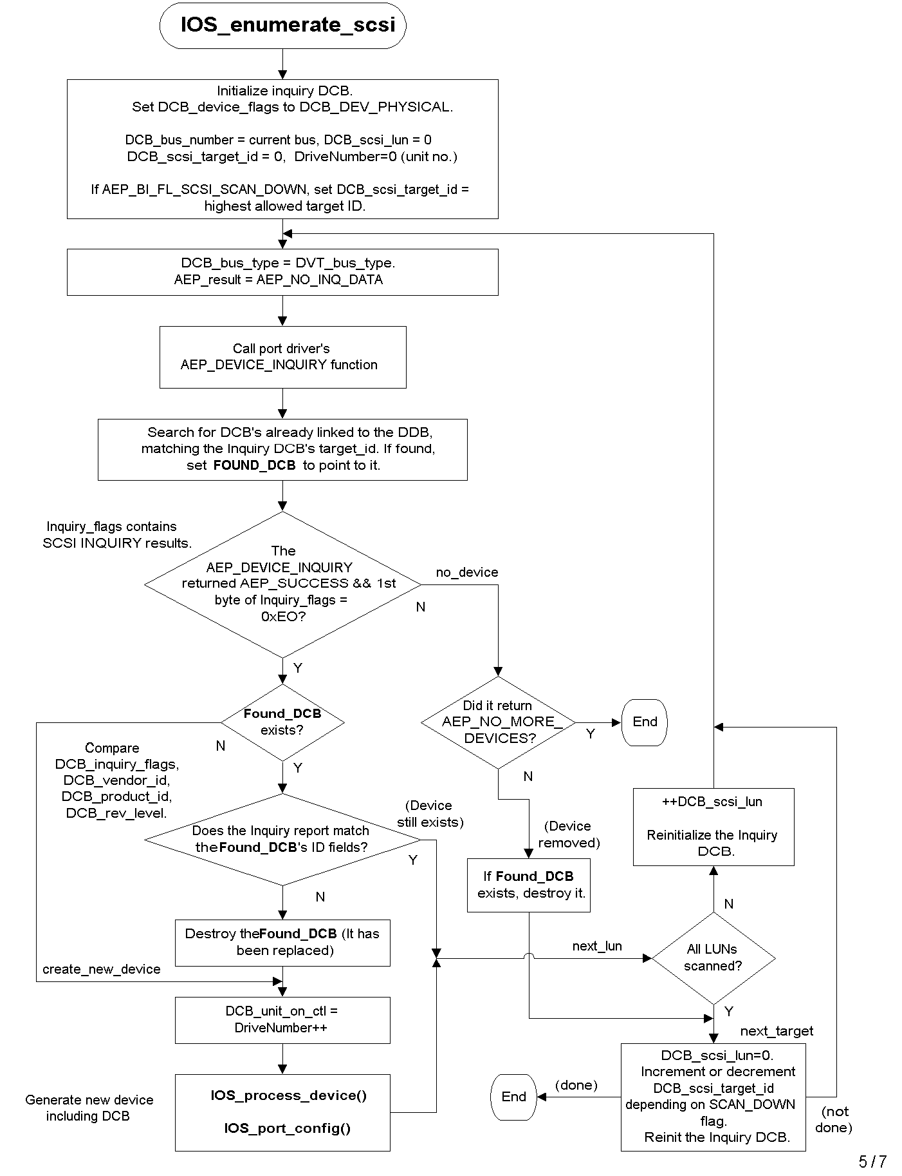
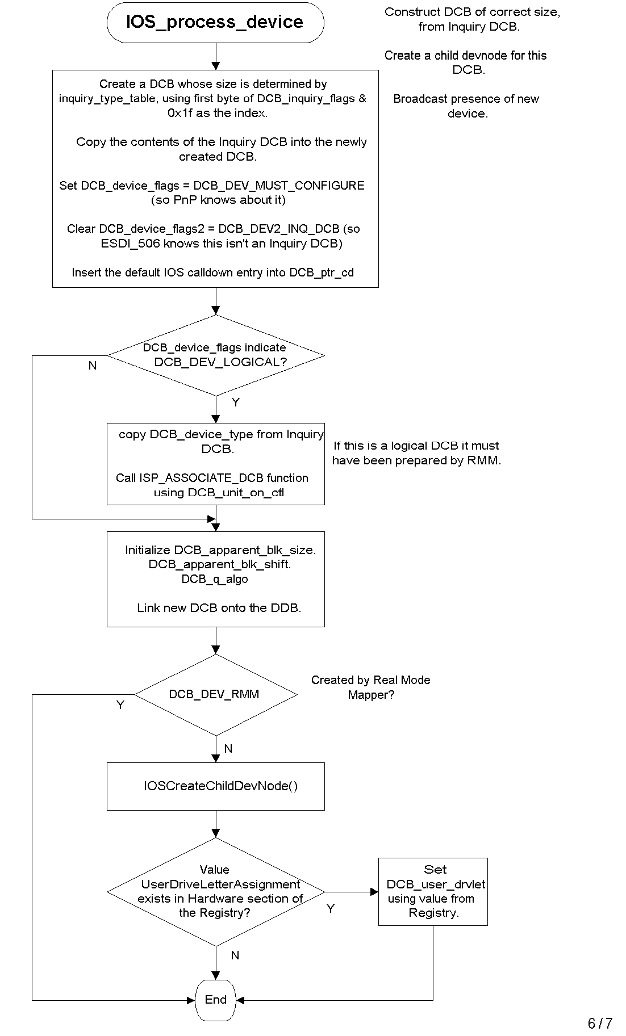
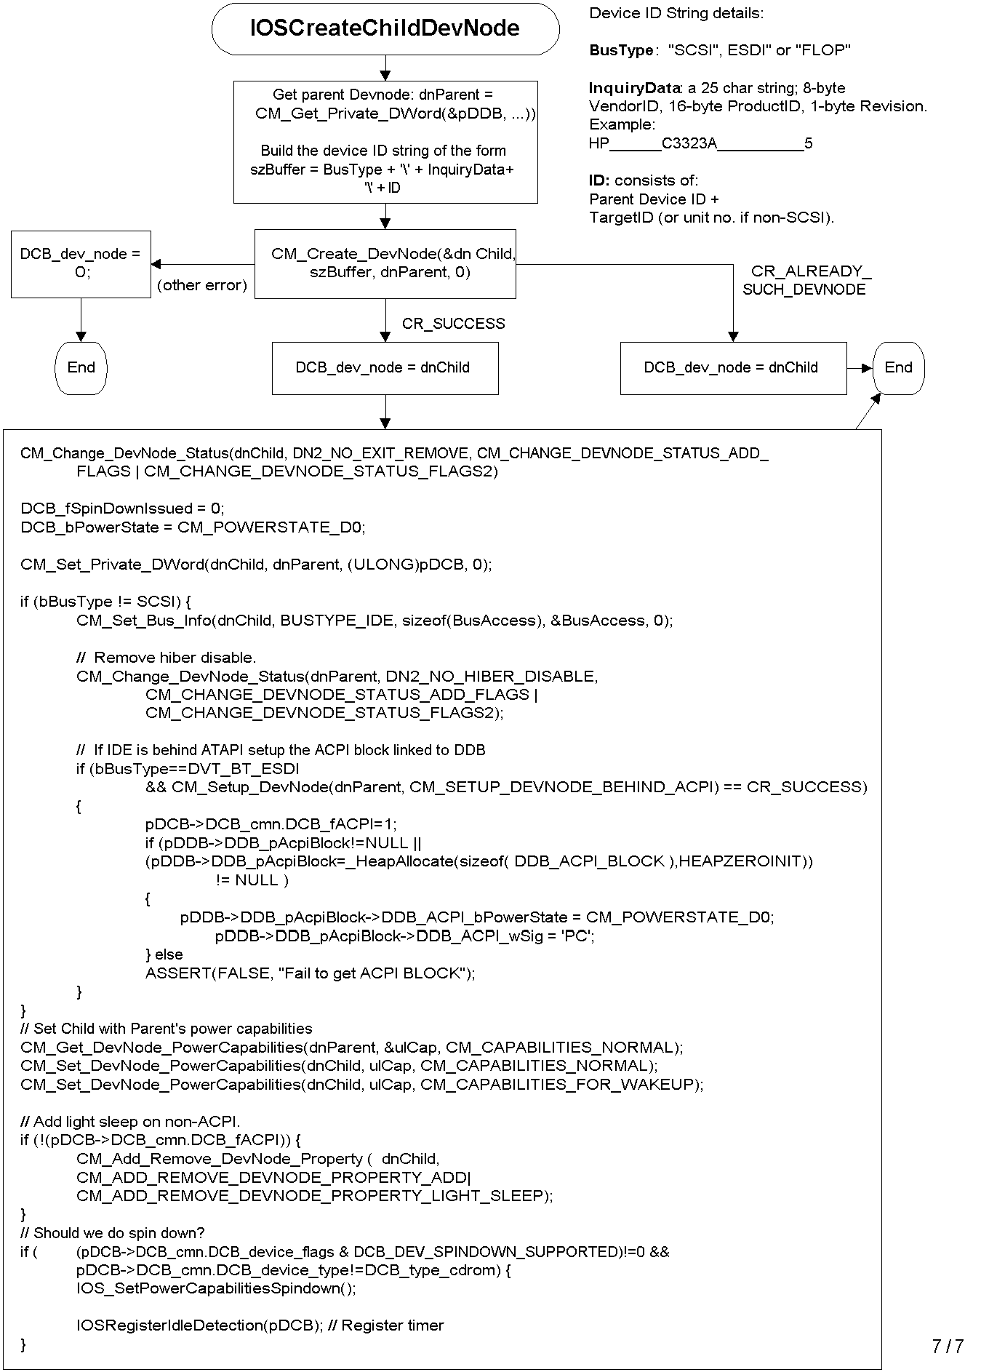

Appendix 4 - IOS Layer Drivers

The following chart supplies general information about the assorted IOS layer drivers, including the criteria used to determine whether or not a layer driver adds itself to the call down chain associated with a DCB it receives during AEP_CONFIG_DCB:

Device | Layer no. | Layer type | AEP_CONFIG_DCB Call down insertion qualifications (tested in the order shown)
VOLTRACK.VXD | 5 | DRP_  VOLTRK_  BIT | - Ignores if !(DCB_device_flags & DCB_DEV_REMOVABLE)  - Hooks if DCB_device_type is DCB_type_floppy  - Ignores if !(DCB_device_flags & DCB_DEV_LOGICAL)  - Hooks if DCB_device_type is DCB_type_disk or DCB_type_cdrom.
CDTSD.VXD | 6 | DRP_  CLASS_ DRV_BIT | - Ignore if not (DCB_device_type == DCB_type_cdrom).  - Ignore if any of the following DCB_dmd_flags bits are set: (DCB_dmd_srb_cdb+DCB_dmd_rsrv_1+DCB_dmd_rsrv_2).
DISKTSD.VXD | 7 | DRP_TSD_  BIT | - Ignore if a logical DCB or if handled by rmm (if DCB_device_flags & (DCB_dev_logical | DCB_dev_rmm))  - Ignore if not a disk (DCB_device_type != DCB_type_disk)  - Ignore if not a floppy (DCB_device_type != DCB_type_floppy)  - Ignore if any of the following DCB_dmd_flags bits are set: (DCB_dmd_srb_cdb+DCB_dmd_rsrv_1+DCB_dmd_rsrv_2).
APIX.VXD | 11 | DRP_SCSI_ LAYER_BIT | - Ignore if not a physical DCB  (!(DCB_device_flags & DCB_dev_physical))  - Ignore if device doesn’t use the SCSI bus  (DCB_Bus_Type != DCB_Bus_SCSI)
CDVSD.VXD | 13 | DRP_VSD_5_ BIT | - Ignore if a logical DCB or if handled by rmm (if DCB_device_flags & (DCB_dev_logical | DCB_dev_rmm))  - Ignore if device doesn’t use the SCSI bus  (DCB_Bus_Type != DCB_Bus_SCSI)  - Ignore if not a CD-ROM (DCB_device_type != DCB_Type_CDROM)  - Accept if device has been forced to use protected mode code or it is safe to use protected mode code. Ignore if MSCDEX is installed.
NECATAPI.VXD | 14 | DRP_VSD_6_ BIT | - Ignore if a logical DCB or if handled by rmm (if DCB_device_flags & (DCB_dev_logical | DCB_dev_rmm))  - Ignore if device doesn’t use the SCSI bus  (DCB_Bus_Type != DCB_Bus_SCSI)  - Ignore if not a CD-ROM (DCB_device_type != DCB_Type_CDROM)  - (This VxD tweaks the CDB if the target device is an NEC ATAPI device).
DISKVSD.VXD | 16 | DRP_VSD_8_ BIT | - Ignore if a logical DCB or if handled by rmm (if DCB_device_flags & (DCB_dev_logical | DCB_dev_rmm))  - Ignore if device doesn’t use the SCSI bus  (DCB_Bus_Type != DCB_Bus_SCSI)  - Ignore if not a disk (DCB_device_type != DCB_Type_disk)  - Accept if !(DCB_inquiry_flags.INQ_dev_type_mod & INQ_mod_removable).  - Otherwise, conditionally accept depending on manufacturer ID (Insite or IOMEGA floptical).
ATAPCHNG.VXD | 16 | DRP_VSD_8_ BIT | - Ignore if a logical DCB or if handled by rmm (if DCB_device_flags & (DCB_dev_logical | DCB_dev_rmm))  - Ignore if neither DCB_port_name == IDEATAPI, or DCB_device_flags2 == DCB_DEV2_ATAPI_DEVICE  - Ignore if not SCSI (DCB_Bus_Type != DCB_Bus_SCSI)  - Ignore if not CD-ROM (DCB_Device_Type!=DCB_Type_CDROM)  - Ignore if LUN=0 (if non zero, it’s a drive the atapi changer created)  - Issue a sense command to the CDROM to identify whether it is a changer; ignore if it isn’t.  - Otherwise take over the CDROM device.
SCSI1HLP.VXD | 15 | DRP_VSD_7_ BIT | - Ignore if a logical DCB or if handled by rmm (if DCB_device_flags & (DCB_dev_logical | DCB_dev_rmm))  - Ignore if device doesn’t use the SCSI bus  (DCB_Bus_Type != DCB_Bus_SCSI)  - Ignore if not a CDROM (DCB_device_type != DCB_Type_CDROM)  - Check the dead_drive_table list. If in the list, and within the revision range specified, set DCB_cd_device_flags |= DCB_CD_FAKE_SCSI1. This will force a “bad” drive to use scsi1 behavior.  - Check the mfg_id_table. If in the table, or if the ANSI version field indicates it is a generic SCSI1 device ((DCB_inquiry_flags[2] & 0000111) < 2), accept it (take over the device).  - Note that when this driver intercepts requests, it will ignore IOR_SCSI_PASS_THROUGH IOP’s.
SMARTVSD.VXD | 17 | DRP_VSD_9_ BIT | - Ignore if a logical DCB or if handled by rmm (if DCB_device_flags & (DCB_dev_logical | DCB_dev_rmm))  - Accept if (DCB_bus_type == DCB_BUS_ESDI) && (DCB_device_type == DCB_type_disk)), or if (DCB_device_flags2 & DCB_DEV2_ATAPI_DEVICE)  - Note that this VxD doesn’t “hook” into the calldown chain. It serves as a ring 3 interface (DeviceIoControl).
SCSIPORT.PDR | 21 | DRP_NT_PD_ BIT | (No qualifications needed – this is a port driver)
ESDI_506.PDR | 22 | DRP_ESDI_PD_BIT | (No qualifications needed – this is a port driver)
HSFLOP.PDR | 27 | DRP_NEC_ FLOPPY_BIT | (No qualifications needed – this is a port driver)
RMM.PDR | 30 | DRP_SOC_ DRV_BIT | (No qualifications needed – this is a port driver)

Appendix 5 - IOS Sample Code

Unless otherwise indicated, the following storage samples are available in the Windows 95 DDK and/or the Windows 98 DDK:

Sample type | Sample name | Comments
SCSI Miniport Driver | PC2X | This is the miniport driver for the Iomega PC2x 8-bit SCSI adapter card. Instead of using this sample, the ATAPI miniport sample described below is the recommended sample.
SCSI Miniport Driver | ATAPI | (Located in the Windows NT 4.0 DDK, not the Windows 95 or Windows 98 DDK) A SCSI miniport driver that when compiled, can be binary compatible between Windows 95/98 and Windows NT/2000 (but is not binary compatible if Windows system calls using VMMCall are compiled in).
IOS Port Driver | PORT | This is an IOS Port device driver sample, serving only as a template for developing a new Port driver. It is written in assembly language. Port drivers reside at the bottom of the IOS layered hierarchy, and typically communicate with storage device hardware. This sample demonstrates how to use ILB_enqueue_IOP and ILB_dequeue_IOP in order to buffer IOPs sent to the driver while the driver is already busy processing an IOP.
IOS Vendor Supplied Driver | VSD | This is an IOS Vendor Supplied Driver device driver sample, serving only as a template for developing a new VSD. This type of driver is sometimes called a helper VSD. VSD drivers reside in the middle of the IOS layered hierarchy, between port drivers and File System Drivers. They can be used to monitor and filter communications between FSDs and port drivers. They can be used to interface ring 3 applications to ring 0 IOS components. The sample is written in assembly language.
IOS Vendor Supplied Driver | PASSTHRU | (Located on our support Web site at http://support.microsoft.com/support/ddk)  A sample VSD based on the HELPVSD sample, which demonstrates how to issue a command to a SCSI device using the SCSI Passthrough technique.
Win 32 Application | WNASPI | A sample ASPI for WIN32 application program linking the WNASPI32.DLL export functions. This application demonstrates how an application can issue pass-through commands to SCSI devices and ATAPI CD-ROMs. For example, tape backup utility programs use this mechanism. Note that Windows 95 also comes with WINASPI.DLL, which is used to support ASPI communications from a 16-bit Windows application.
S.M.A.R.T. Application | SMARTAPP | (Located via Knowledge Base article Q208048)  SmartApp.exe is a sample Win32 application that demonstrates how to access the SMART (Self Monitoring, Analysis and Reporting Technology) capabilities built into IDE disk drives.  SMART technology is used to monitor disk drive degradation, in an effort to predict future catastrophic disk failure.

Setting up and compiling sample code

With the exception of the SMARTAPP sample, the above samples will compile successfully using NMAKE when the Windows 95 DDK is used, or BUILD when the Windows 98 DDK is used. Refer to the corresponding DDK for details. The SMARTAPP sample will build using Visual Studio.

Supplemental Listings

Listing 1 – PCD (Platform Configuration Data) Structures

/* Definitions for PCD Types */

#define PCD_TYPE_FIXED_DISK 0 /* PCD for fixed disk */
#define PCD_TYPE_FLOPPY_DISK 1 /* PCD for floppy disk */
#define PCD_TYPE_NEW_FIXED_DISK 2 /* fake PCD for new disk */

typedef struct PCD_generic { /* */

UCHAR PCD_type; /* see types above */
ULONG PCD_delta_next; /* delta to next PCD or zero if none */

} PCD, *pnPCD, far *pfPCD, far *pPCD;

/*
** define the fixed disk PCD
*/

typedef struct PCD_fixed_disk { /* */

UCHAR PCD_filler_0; /* "PCD_TYPE_FIXED_DISK"*/
ULONG PCD_filler_1; /* PCD_delta_next*/
UCHAR PCD_fixed_unit_number; /* unit number (80-ffh) */
USHORT PCD_fixed_cyl_cnt; /* total number of cylinders */
USHORT PCD_fixed_head_cnt; /* total number of heads */
USHORT PCD_fixed_spt; /* sectors/track */
UCHAR PCD_fixed_flags ;
} PCD_fixed_disk, near *pnPCD_fixed_disk, far *pfPCD_fixed_disk, far *pPCD_fixed_disk;

#define PCD_FIXED_FL_EXTINT13 0x01

typedef struct PCD_ext_int13 { /* */
USHORT PCD_X13_res ;
USHORT PCD_X13_flags ;
ULONG PCD_X13_cyl_cnt ;
ULONG PCD_X13_head_cnt ;
ULONG PCD_X13_spt ;
ULONG PCD_X13_sec_cnt_lo ;
ULONG PCD_X13_sec_cnt_hi ;
USHORT PCD_X13_sec_size ;
} PCD_ext_int13 ;

typedef struct PCD_X13_fixed_disk { /* */
struct PCD_fixed_disk PCD_fixed_13 ;
struct PCD_ext_int13 PCD_fixed_x13 ;
} PCD_X13_fixed_disk ;

/*
** define the floppy disk PCD
*/

typedef struct _DPT_floppy_disk { /* */

UCHAR DPT_floppy_spec1; /* step rate time, head unload time */
UCHAR DPT_floppy_spec2; /* head load time, DMA mode */
UCHAR DPT_floppy_wait_time; /* wait time until diskette motor off */
UCHAR DPT_floppy_b_p_s; /* bytes per sector: 0=128 1=256 2=512 3=1024 */
UCHAR DPT_floppy_l_s_n; /* last sector number */
UCHAR DPT_floppy_gap_len; /* gap length between sectors (r/w) */
UCHAR DPT_floppy_data_len; /* data length when no sector length */
UCHAR DPT_floppy_gap_lenf; /* gap length between sectors (format) */
UCHAR DPT_floppy_f_d_v; /* data value stored in formatted sectors */
UCHAR DPT_floppy_h_s_t; /* head settle time */
UCHAR DPT_floppy_m_s_t; /* motor start-up time */
} DPT_floppy_disk;

typedef struct PCD_floppy_disk { /* */

UCHAR PCD_filler_2; /* "PCD_TYPE_FLOPPY_DISK" */
ULONG PCD_filler_3; /* PCD_delta_next */

UCHAR PCD_floppy_unit_number; /* unit number (00-7fh) */

USHORT PCD_floppy_cyl_cnt; /* total number of cylinders */
USHORT PCD_floppy_head_cnt; /* total number of heads */
USHORT PCD_floppy_spt; /* sectors/track */

UCHAR PCD_floppy_drive_type; /* CMOS drive type */
/* 01 = 5.25", 360k, 40 track */
/* 02 = 5.25", 1.2M, 80 track */
/* 03 = 3.5", 720K, 80 track */
/* 04 = 3.5", 1.44M, 80 track */
UCHAR PCD_floppy_flags;

/* definition for diskette parameter table follows */

DPT_floppy_disk PCD_floppy_dpt;

ULONG PCD_floppy_dpt_addr;

} PCD_floppy_disk, near *pnPCD_floppy_disk, far *pfPCD_floppy_disk, far *pPCD_floppy_disk;

// OR PCD_floppy_flags with this to specify that it supports change line
#define PCD_FLAGS_FLP_CHG_LINE_SUPPORT 0x01

Listing 2 – LDM (Logical Device Map) Structures

typedef struct LDM { /* */
UCHAR LDM_drive_letter; /* numeric drive letter equivalent (00 = a:) */
/* FFh indicates end of table */
UCHAR LDM_int13_unit; /* int 13 unit number, or FFh if none */
ULONG LDM_serial_number; /* serial number from the volume boot record */
ULONG LDM_starting_rba; /* starting RBA of this logical volume */
UCHAR LDM_aspi_target; /* aspi target id */
UCHAR LDM_aspi_lun; /* aspi lun */
UCHAR LDM_aspi_bus; /* aspi bus number */
UCHAR LDM_cam_target; /* cam target id */
UCHAR LDM_cam_lun; /* cam lun */
UCHAR LDM_cam_bus; /* cam bus number */
USHORT LDM_flags; /* flags as defined below */
} LDM, *pLDM;

/*
** IDM_flags definitions follow
*/

#define LDM_FL_CLAIMED_BIT 0x00 /* logical dev claimed in protected mode */
#define LDM_FL_CLAIMED 1 << LDM_FL_CLAIMED_BIT
#define LDM_FL_INVALID_MEDIA_BIT 1
#define LDM_FL_INVALID_MEDIA 0x02 /* the logical volume is invalid */
#define LDM_FL_REAL_MODE_ONLY 0x04 /* device must be handled by RM driver */
#define LDM_FL_UNSAFE_HOOK 0x08 /* device driver has been hooked */
#define LDM_FL_HOOKED LDM_FL_UNSAFE_HOOK
#define LDM_FL_MONO 0x10 /* unit controlled by monolithic drvr*/

Listing 3 – DVT_feature_code Definitions

#define DVT_FC_SCAN_DOWN 0x04 /* on = bios scans targets from high to low*/
#define DVT_FC_IO_FOR_INQ_AEP 0x40 /* on = PD needs to send I/O through IOP in response to an
INQUIRY AEP. Results in CONFIGURE AEP for INQUIRY DCB.*/
#define DVT_FC_HALF_SEC 0x2000 /* on = notify driver every half second */
#define DVT_FC_1_SEC 0x2000 /* on = notify driver every second */
#define DVT_FC_2_SECS 0x4000 /* on = notify driver every two seconds */
#define DVT_FC_4_SECS 0x8000 /* on = notify driver every four seconds */
#define DVT_FC_DYNALOAD 0x10000 /* on = driver was dynaloaded by IOS */
#define DVT_FC_NEED_PRELOAD 0x20000 /* on = driver needs to hook I/O even before the
port driver. AEP_config_dcb will be received
before PD when set */
#define DVT_FC_NEED_PRE_POST_LOAD 0x40000
#define DVT_FC_SUPPORT_ESDI_REENUMERATION 0x80000 /* handle INQUIRY for reenumeration (along with DCB_DEV2_INQ_DCB) */
#define DVT_FC_NTMAP 0x100000

See DCB.H for more info regarding these fields.

Listing 4 - Sample .IDUMP report

The debug version of IOS.VXD offers assorted dot commands (use .I? for a summary).

For each of the dot commands that begin with .ID…, fields are reported in the form <symbol name>’@’<offset>, where <offset> is the numeric (hex) offset of the field within the parent structure. This information is reported only to facilitate debugging, since these offset values may vary with the version of operating system used.

Definitions for these fields are contained in Appendix 2 - IOS internal data structure detail.

For best results, install the symbol files for every IOS layer possible, in order to see symbolic addresses in these reports.

A sample debugger dump follows.

1##.i?
*** I/O Subsystem debug help ***
.IIOP <exp> - dumps IOP/IOR/IOR callback structures for specified address
.IDCB <exp> - dumps DCB and the calldown table lists for specified address
or specify 0-19h for DCB from logical_drive_table
.IMED - lists IOS Memory Pool entries
.ILDCB - lists the DCBS
.ILDVT - lists the devices
.IDUMP - comprehensive structured dump of IOS components
.IDIDA - full IOS data area dump
.IDDVT <exp> - full DVT dump
.IDDCB <exp> - full DCB dump
1##.idump
====================================================================================
c0fcf000 IDA (IOS Data Area)
ios_mem_phys@08 00fdf000 ios_timer@10 000000d8
esdi_p_in_use@20 ee esdi_s_in_use@21 ee Num_Floppies@22 01
platform@24 0001 flags@28 00000041 rm_irq@6C 0001

platform_config_data@2C c03e082a first_dcb@30 cb5d3c10
logical_dev_map@34 c14c83d0 physical_dev_map@38 c03e0e8a
rmm_phys_dcb@3C 00000000 first_vrp@40 c159b550
drive_letter_map@44 0000001f cdrom_letter_map@48 00000000
rmd_ptr@4C c2902067 aspi_cam_rmds@50 00000000
big_mem_buf_virt@54 c0fdf000 big_mem_buf_phys@58 00fef000
big_mem_buf_size@5C 00010000 ios_mem_pool_size@60 0000ff92

--- Other non-IDA internal IOS static info ---
logical_drive_table c008228c IOSPanicHead 00000000
physical_drive_table c00822f4 IOSInitFlags 0000059c
physical_floppy_table c0082354 SemTabInd ff
IOS_Int13_Device_Chain cb5d3343 MemSem c146d0e0
SemTab c0082376 SemTabSem c146d170
Inquiry_DCB c15a72b0 MemBlockers 00

====================================================================================
c155bf10 DVT: ascii_name@14[hsflop.pdr ] current_lgn@44[1b] DRP_NEC_FLOPPY
rev_level@34[ ( '] create_date@24[ ] create_time@2C[ ' ]

ddb@0C[c155bf70] next_dvt@02[c1582e40] ddb_init@10[c155bf70]

device_cnt@06 0001 feature_code@38 00002040
init_count@4F 01 if_requirements@3C 00ff
bus_type@3E 02 reference_data@3F 00000000
first_drive@43 ee LoadHandle@45 c155bee0
scsi_max_target@49 00 entry_point@4B dbe50101
scsi_max_lun@4A 03 aer@08 c1578e5c (%c1578e5c)

====================================================================================
c155bf70 DDB Driver Data Block for DVT driver named hsflop.pdr
dvt@14 c155bf10 Next_DDB@04 00000000 Next_DDB_init@08 00000000
dcb_ptr@0C cb5d3c10 devnode_ptr@18 c29e76e0 number_buses@10 01
ios_flags@11 08 sig@12 4442 phys_addr@00 da0c0101

====================================================================================
cb5d3c10 Logical+Physical DCB (NEC FLOPPY DISK) bus= NEC
--- DCB_common area ---
physical_dcb@00 cb5d3c10 track_table_ptr@2C 00000000 apparent_blk_shift@3C 09
expansion_length@04 00000004 bds_ptr@30 c28283b0 partition_type@3D 00
ptr_cd@08 c14bc840 Reserved1@34 00000000 disk_bpb_flags@45 00
next_dcb@0C cb5d3280 pEid@38 00000000 cAssoc@46 02
next_logical_dcb@10 00000000 Exclusive_VM@41 00000000 Sstor_Host@47 00
vrp_ptr@18 c14eff20 sig@3E 4342 user_drvlet@48 ffff
dmd_flags@1C 00642800 TSD_Flags@16 0000 fACPI@4C 00
device_flags@20 1018d007 drive_lttr_equiv@14 00 fSpinDownIssued@4D 00
device_flags2@24 00000000 unit_number@15 00 bPowerState@4E 01
Partition_Start@28 00000000 device_type@40 0a bEidLength@4F 00

--- DCB physical data extension ---------------------
product_id@92 NEC FLOPPY DISK bus_type@74 02 bus_number@75 00
vendor_id@8A GENERIC current_unit@AE 00 max_sg_elements@77 11
rev_level@A2 queue_freeze@76 00 io_pend_count@78 00
port_name@A6 lock_count@79 00 srb_ext_size@80 0000
q_algo@B9 01 max_sense_data_len@7F 00 unit_on_ctl@BA 00
Vol_Flags@B8 00 access_timer@B7 18 next_ddb_dcb@6C 00000000

dev_node@70 c2a5be70 inquiry_flags@82 1e 00 00 00 00 00 00 00
blocked_iop@AF 00000000 vol_unlock_timer@B3 00000000
Port_Specific@BB c155c090 spindown_timer@BF 00000000
max_xfer_len@50 ffffffff actual_sector_cnt@54 0000000000000b40
SCSI_VSD_FLAGS@7A 0000 actual_blk_size@5C 00000200
scsi_target_id@7C 00 actual_head_cnt@60 00000002
scsi_lun@7D 00 actual_cyl_cnt@64 00000050
scsi_hba@7E 00 actual_spt@68 00000012

--- DCB_BLOCKDEV (INT13) data extension -------------
BDD_Device_SubType@C9 00 apparent_sector_cnt@D3 0000000000000b40
BDD_Int_13h_Number@CA 00 apparent_blk_size@DB 00000200
BDD_BD_Major_Version@C7 00 apparent_head_cnt@DF 00000002
BDD_BD_Minor_Version@C8 00 apparent_cyl_cnt@E3 00000050
BDD_flags@CB 00000000 apparent_spt@E7 00000012
BDD_Name_Ptr@CF 00000000 BDD_Sync_Cmd_Proc@EB 00000000
BDD_Next@C3 00000000 BDD_Command_Proc@EF 00000000
BDD_Hw_Int_Proc@F3 00000000 BDP_Current_Flags@FF 00000000
BDP_Int13_Param_Ptr@103 00000000 BDP_Current_Command@107 00000000
fastdisk_bdd@127 00000000 BDP_Current_Position@10B 0000000000000000
BDP_Cmd_Queue_Ascending@F7 00000000
BDP_Cmd_Queue_Descending@FB 00000000

----- DCB_ptr_cd Calldown Entry List (DCB_cd_...) -----
expan_ layer
At: flagss@4 ddb@8 off@10 flags@12 ----- lgn@13 ----- io_address@0
c14bc840 00642800 00000000 fffc 00 05 DRP_VOLTRK voltrack:_LGROUP:vol_request
c1410a10 00640800 c0fdef5c fffc 00 07 DRP_TSD disktsd:_LGROUP:tsd_request
c1410a50 00640800 c155bf70 0000 00 1b DRP_NEC_FLOPPY %c1578674
c00823eb 00000000 00000000 0000 00 1f DRP_IOS_REG %c00887bb

====================================================================================
c1582e40 DVT: ascii_name@14[esdi_506.pdr ] current_lgn@44[16] DRP_ESDI_PD
rev_level@34[ ] create_date@24[ ] create_time@2C[ ]

ddb@0C[c1582ea0] next_dvt@02[c1579080] ddb_init@10[c1572480]

device_cnt@06 0004 feature_code@38 00080040
init_count@4F 02 if_requirements@3C 0000
bus_type@3E 00 reference_data@3F 00000000
first_drive@43 42 LoadHandle@45 c1582dc0
scsi_max_target@49 00 entry_point@4B 3277ba0f
scsi_max_lun@4A 00 aer@08 c1581050 (esdi_506:_LDATA:ESDI_async_event)

====================================================================================
c1582ea0 DDB Driver Data Block for DVT driver named esdi_506.pdr
dvt@14 c1582e40 Next_DDB@04 c1572480 Next_DDB_init@08 00000000
dcb_ptr@0C cb5d3280 devnode_ptr@18 c29f3e80 number_buses@10 00
ios_flags@11 08 sig@12 4442 phys_addr@00 66805ec1

--- c155c180 pAcpiBlock found in above DDB ---
tm_PIOSpeed0@00 00000000 hTaskFile@18 00000000 00000000
tm_DMASpeed0@04 00000000 dwEidLength@20 00000000 00000000
tm_PIOSpeed1@08 00000000 dwEid@28 00000000 00000000
tm_DMASpeed1@0C 00000000 dwTaskFileLength@30 00000000 00000000
tm_Flags@10 00000000 dwTaskFile@38 00000000 00000000
bPowerState@14 01 bIdeLevel@15 00 wSig@16 5043

====================================================================================
cb5d3280 Physical DCB (IDE DISK TYPE01) bus= IDE
--- DCB_common area ---
physical_dcb@00 cb5d3280 track_table_ptr@2C 00000000 apparent_blk_shift@3C 09
expansion_length@04 0000004c bds_ptr@30 00000000 partition_type@3D 00
ptr_cd@08 c1582f20 Reserved1@34 00000000 disk_bpb_flags@45 00
next_dcb@0C cb5d3d50 pEid@38 c1582f40 cAssoc@46 00
next_logical_dcb@10 cb5d3d50 Exclusive_VM@41 00000000 Sstor_Host@47 00
vrp_ptr@18 00000000 sig@3E 4342 user_drvlet@48 ffff
dmd_flags@1C 00000000 TSD_Flags@16 4008 fACPI@4C 01
device_flags@20 91208103 drive_lttr_equiv@14 00 fSpinDownIssued@4D 00
device_flags2@24 00000000 unit_number@15 80 bPowerState@4E 01
Partition_Start@28 00000000 device_type@40 00 bEidLength@4F 01

--- DCB physical data extension ---------------------
product_id@92 IDE DISK TYPE01 bus_type@74 00 bus_number@75 00
vendor_id@8A GENERIC current_unit@AE 00 max_sg_elements@77 11
rev_level@A2 queue_freeze@76 00 io_pend_count@78 00
port_name@A6 ESDI_506 lock_count@79 00 srb_ext_size@80 0000
q_algo@B9 01 max_sense_data_len@7F 00 unit_on_ctl@BA 00
Vol_Flags@B8 00 access_timer@B7 00 next_ddb_dcb@6C 00000000

dev_node@70 c2a5a9e0 inquiry_flags@82 00 00 00 00 00 00 00 00
blocked_iop@AF 00000000 vol_unlock_timer@B3 00000000
Port_Specific@BB c1582f40 spindown_timer@BF 00000000
max_xfer_len@50 ffffffff actual_sector_cnt@54 0000000000ebc9e0
SCSI_VSD_FLAGS@7A 0000 actual_blk_size@5C 00000000
scsi_target_id@7C 00 actual_head_cnt@60 0000000f
scsi_lun@7D 00 actual_cyl_cnt@64 00003ffd
scsi_hba@7E 00 actual_spt@68 0000003f

--- DCB_BLOCKDEV (INT13) data extension -------------
BDD_Device_SubType@C9 00 apparent_sector_cnt@D3 0000000000ebc9e0
BDD_Int_13h_Number@CA 80 apparent_blk_size@DB 00000200
BDD_BD_Major_Version@C7 00 apparent_head_cnt@DF 000000f0
BDD_BD_Minor_Version@C8 00 apparent_cyl_cnt@E3 000003fe
BDD_flags@CB 00000003 apparent_spt@E7 0000003f
BDD_Name_Ptr@CF 00000000 BDD_Sync_Cmd_Proc@EB 00000000
BDD_Next@C3 00000000 BDD_Command_Proc@EF 00000000
BDD_Hw_Int_Proc@F3 00000000 BDP_Current_Flags@FF 00000000
BDP_Int13_Param_Ptr@103 00000000 BDP_Current_Command@107 00000000
fastdisk_bdd@127 00000000 BDP_Current_Position@10B 000000000008adbc
BDP_Cmd_Queue_Ascending@F7 00000000
BDP_Cmd_Queue_Descending@FB 00000000

--- DCB_disk data extension -------------------
write_precomp@12B 0000 disk_tsd_private@12D 00000000

----- DCB_ptr_cd Calldown Entry List (DCB_cd_...) -----
expan_ layer
At: flagss@4 ddb@8 off@10 flags@12 ----- lgn@13 ----- io_address@0
c1582f20 00000000 c0fdef5c ffb4 00 07 DRP_TSD disktsd:_LGROUP:tsd_request
c1579fd0 00000000 c1582ea0 ffb8 00 16 DRP_ESDI_PD esdi_506:_LDATA:ESDI_Request
c00823eb 00000000 00000000 0000 00 1f DRP_IOS_REG %c00887bb

====================================================================================
cb5d3d50 Logical DCB
--- DCB_common area ---
physical_dcb@00 cb5d3280 track_table_ptr@2C 00000000 apparent_blk_shift@3C 09
expansion_length@04 0000004c bds_ptr@30 c28284dc partition_type@3D 0b
ptr_cd@08 c14bc860 Reserved1@34 00000000 disk_bpb_flags@45 00
next_dcb@0C cb5d3da0 pEid@38 c1582f40 cAssoc@46 01
next_logical_dcb@10 cb5d3da0 Exclusive_VM@41 00000000 Sstor_Host@47 00
vrp_ptr@18 c1576a30 sig@3E 4342 user_drvlet@48 ffff
dmd_flags@1C 00000000 TSD_Flags@16 4008 fACPI@4C 01
device_flags@20 81204103 drive_lttr_equiv@14 02 fSpinDownIssued@4D 00
device_flags2@24 00000000 unit_number@15 00 bPowerState@4E 01
Partition_Start@28 0000003f device_type@40 00 bEidLength@4F 01

----- DCB_ptr_cd Calldown Entry List (DCB_cd_...) -----
expan_ layer
At: flagss@4 ddb@8 off@10 flags@12 ----- lgn@13 ----- io_address@0
c14bc860 00000000 c0fdef5c ffb4 00 07 DRP_TSD disktsd:_LGROUP:tsd_request
c14f0540 00000000 c1582ea0 ffb8 00 16 DRP_ESDI_PD esdi_506:_LDATA:ESDI_Request
c157a010 00000000 00000000 0000 00 1f DRP_IOS_REG %c00887bb

====================================================================================
cb5d3da0 Logical DCB
--- DCB_common area ---
physical_dcb@00 cb5d3280 track_table_ptr@2C 00000000 apparent_blk_shift@3C 09
expansion_length@04 0000004c bds_ptr@30 c2828572 partition_type@3D 0b
ptr_cd@08 c14bc880 Reserved1@34 00000000 disk_bpb_flags@45 00
next_dcb@0C cb5d3df0 pEid@38 c1582f40 cAssoc@46 01
next_logical_dcb@10 00000000 Exclusive_VM@41 00000000 Sstor_Host@47 00
vrp_ptr@18 c159b550 sig@3E 4342 user_drvlet@48 ffff
dmd_flags@1C 00000000 TSD_Flags@16 4008 fACPI@4C 01
device_flags@20 81204003 drive_lttr_equiv@14 03 fSpinDownIssued@4D 00
device_flags2@24 00000000 unit_number@15 00 bPowerState@4E 01
Partition_Start@28 003e862f device_type@40 00 bEidLength@4F 01

----- DCB_ptr_cd Calldown Entry List (DCB_cd_...) -----
expan_ layer
At: flagss@4 ddb@8 off@10 flags@12 ----- lgn@13 ----- io_address@0
c14bc880 00000000 c0fdef5c ffb4 00 07 DRP_TSD disktsd:_LGROUP:tsd_request
c14f0560 00000000 c1582ea0 ffb8 00 16 DRP_ESDI_PD esdi_506:_LDATA:ESDI_Request
c1576aa0 00000000 00000000 0000 00 1f DRP_IOS_REG %c00887bb

====================================================================================
c1572480 DDB Driver Data Block for DVT driver named esdi_506.pdr
dvt@14 c1582e40 Next_DDB@04 00000000 Next_DDB_init@08 00000000
dcb_ptr@0C cb5d3df0 devnode_ptr@18 c2a06020 number_buses@10 00
ios_flags@11 08 sig@12 4442 phys_addr@00 0000454c

--- c140a790 pAcpiBlock found in above DDB ---
tm_PIOSpeed0@00 00000000 hTaskFile@18 00000000 00000000
tm_DMASpeed0@04 00000000 dwEidLength@20 00000000 00000000
tm_PIOSpeed1@08 00000000 dwEid@28 00000000 00000000
tm_DMASpeed1@0C 00000000 dwTaskFileLength@30 00000000 00000000
tm_Flags@10 00000000 dwTaskFile@38 00000000 00000000
bPowerState@14 01 bIdeLevel@15 00 wSig@16 5043

====================================================================================
cb5d3df0 Logical+Physical DCB (CRD-8322B ) bus= SCSI
--- DCB_common area ---
physical_dcb@00 cb5d3df0 track_table_ptr@2C 00000000 apparent_blk_shift@3C 0b
expansion_length@04 000000d0 bds_ptr@30 00000000 partition_type@3D 00
ptr_cd@08 c140a7f0 Reserved1@34 00000000 disk_bpb_flags@45 00
next_dcb@0C 00000000 pEid@38 c1410b10 cAssoc@46 01
next_logical_dcb@10 00000000 Exclusive_VM@41 00000000 Sstor_Host@47 00
vrp_ptr@18 00000000 sig@3E 4342 user_drvlet@48 ffff
dmd_flags@1C 00070000 TSD_Flags@16 0000 fACPI@4C 01
device_flags@20 d039d004 drive_lttr_equiv@14 04 fSpinDownIssued@4D 00
device_flags2@24 00000002 unit_number@15 04 bPowerState@4E 01
Partition_Start@28 00000000 device_type@40 05 bEidLength@4F 01

--- DCB physical data extension ---------------------
product_id@92 CRD-8322B bus_type@74 01 bus_number@75 00
vendor_id@8A COMPAQ current_unit@AE 00 max_sg_elements@77 11
rev_level@A2 1.03 queue_freeze@76 00 io_pend_count@78 00
port_name@A6 ESDI_506 lock_count@79 00 srb_ext_size@80 0000
q_algo@B9 00 max_sense_data_len@7F 0e unit_on_ctl@BA 00
Vol_Flags@B8 00 access_timer@B7 43 next_ddb_dcb@6C 00000000

dev_node@70 c2a6a030 inquiry_flags@82 05 80 02 21 1f 00 00 00
blocked_iop@AF 00000000 vol_unlock_timer@B3 00000000
Port_Specific@BB c1410b10 spindown_timer@BF 00000000
max_xfer_len@50 ffffffff actual_sector_cnt@54 0000000000000000
SCSI_VSD_FLAGS@7A 0000 actual_blk_size@5C 00000000
scsi_target_id@7C 00 actual_head_cnt@60 00000001
scsi_lun@7D 00 actual_cyl_cnt@64 00000001
scsi_hba@7E 01 actual_spt@68 00000001

--- DCB_BLOCKDEV (INT13) data extension -------------
BDD_Device_SubType@C9 00 apparent_sector_cnt@D3 0000000000000000
BDD_Int_13h_Number@CA 04 apparent_blk_size@DB 00000800
BDD_BD_Major_Version@C7 00 apparent_head_cnt@DF 00000000
BDD_BD_Minor_Version@C8 00 apparent_cyl_cnt@E3 00000000
BDD_flags@CB 00000004 apparent_spt@E7 00000000
BDD_Name_Ptr@CF 00000000 BDD_Sync_Cmd_Proc@EB 00000000
BDD_Next@C3 00000000 BDD_Command_Proc@EF 00000000
BDD_Hw_Int_Proc@F3 00000000 BDP_Current_Flags@FF 00000000
BDP_Int13_Param_Ptr@103 00000000 BDP_Current_Command@107 00000000
fastdisk_bdd@127 00000000 BDP_Current_Position@10B 0000000000000001
BDP_Cmd_Queue_Ascending@F7 00000000
BDP_Cmd_Queue_Descending@FB 00000000

--- DCB_CDROM data extension -------------------
cdrom_Partition_Start@12B 00000000 TOC@134 cb5d3f24
cdrom_Partition_End@12F 00000000 cd_first_session@474 00
cd_mode_sense_buf@45C cb5d424c cd_last_session@475 00
cd_last_session_start@48C 00000000 cd_fs_lt@486 00
cd_current_block_size@490 00000000 cd_bobbit_pt@487 00
cd_current_command@4BC 00000000 cd_ls_ft@133 00
play_resume_start@476 00000000 cd_queue_head@4A0 00000000
play_resume_stop@47A 00000000 play_status@47E 00000000
cd_device_flags@482 00001400 cd_fs_lo@488 00000000
cd_vol_map@494 01 ff 02 ff 00 00 00 00

----- DCB_ptr_cd Calldown Entry List (DCB_cd_...) -----
expan_ layer
At: flagss@4 ddb@8 off@10 flags@12 ----- lgn@13 ----- io_address@0
c140a7f0 00070000 00000000 ff30 00 05 DRP_VOLTRK voltrack:_LGROUP:vol_request
c1576b50 00070000 00000000 ff30 00 06 DRP_CLASS_DRV cdtsd:_LGROUP:tsd_request
c1576b30 00070008 c1401fb0 ff30 00 0d DRP_VSD_5 cdvsd:.bss:VSD_Request
c15120c0 00000000 c1576b20 ff94 00 0f DRP_VSD_7 scsi1hlp:_LGROUP:HLP_request
c15120e0 00000000 c1572480 ffb8 00 16 DRP_ESDI_PD esdi_506:_LDATA:ESDI_Request
c00823eb 00000000 00000000 0000 00 1f DRP_IOS_REG %c00887bb

====================================================================================
c1579080 DVT: ascii_name@14[scsiport.pdr ] current_lgn@44[15] DRP_NT_PD
rev_level@34[ ] create_date@24[ ] create_time@2C[ ]

ddb@0C[00000000] next_dvt@02[c1580eb0] ddb_init@10[00000000]

device_cnt@06 0000 feature_code@38 00000000
init_count@4F 00 if_requirements@3C 0000
bus_type@3E 01 reference_data@3F 00000000
first_drive@43 00 LoadHandle@45 c1580be0
scsi_max_target@49 01 entry_point@4B 00000000
scsi_max_lun@4A 00 aer@08 00000000 (%00000000)

====================================================================================
c1580eb0 DVT: ascii_name@14[aic78xx.mpd ] current_lgn@44[14] DRP_NT_MPD
rev_level@34[Requ] create_date@24[__VCOMM_] create_time@2C[Dequeue_]

ddb@0C[cbbd4000] next_dvt@02[c14c1af0] ddb_init@10[00000000]

device_cnt@06 0000 feature_code@38 00000040
init_count@4F 01 if_requirements@3C 0000
bus_type@3E 01 reference_data@3F c1410ab0
first_drive@43 5f LoadHandle@45 c1579120
scsi_max_target@49 0f entry_point@4B c2a5bfe0
scsi_max_lun@4A 07 aer@08 c15807a4 (scsiport:.data:Async_Event_Handler)

====================================================================================
cbbd4000 DDB Driver Data Block for DVT driver named aic78xx.mpd
dvt@14 c1580eb0 Next_DDB@04 00000000 Next_DDB_init@08 00000000
dcb_ptr@0C 00000000 devnode_ptr@18 c29fc700 number_buses@10 01
ios_flags@11 0a sig@12 4442 phys_addr@00 00fbd000

====================================================================================
c14c1af0 DVT: ascii_name@14[bigmem.drv ] current_lgn@44[12] DRP_RESRVD18
rev_level@34[ ] create_date@24[ ( ] create_time@2C[ i ]

ddb@0C[00000000] next_dvt@02[c14b23c0] ddb_init@10[00000000]

device_cnt@06 0000 feature_code@38 00000000
init_count@4F 00 if_requirements@3C 0000
bus_type@3E 00 reference_data@3F 00000000
first_drive@43 a2 LoadHandle@45 c14f0580
scsi_max_target@49 27 entry_point@4B 031a0102
scsi_max_lun@4A 00 aer@08 c14bc8ac (%c14bc8ac)

====================================================================================
c14b23c0 DVT: ascii_name@14[scsi1hlp.vxd ] current_lgn@44[0f] DRP_VSD_7
rev_level@34[%Zel] create_date@24[@0$pT ?_] create_time@2C[ D6Vru ]

ddb@0C[00000000] next_dvt@02[c148e3d0] ddb_init@10[00000000]

device_cnt@06 0000 feature_code@38 00000000
init_count@4F 00 if_requirements@3C 0000
bus_type@3E 00 reference_data@3F 00000000
first_drive@43 0d LoadHandle@45 c14c90a0
scsi_max_target@49 4e entry_point@4B 3f6e2b8b
scsi_max_lun@4A fe aer@08 c14f012c (%c14f012c)

====================================================================================
c148e3d0 DVT: ascii_name@14[cdvsd.vxd ] current_lgn@44[0e] DRP_VSD_6
rev_level@34[cFpb] create_date@24[- eo6~ ] create_time@2C[v WD0 ]

ddb@0C[00000000] next_dvt@02[c14c1bb0] ddb_init@10[00000000]

device_cnt@06 0000 feature_code@38 00004000
init_count@4F 00 if_requirements@3C 0000
bus_type@3E 00 reference_data@3F 00000000
first_drive@43 0c LoadHandle@45 c14f4080
scsi_max_target@49 e6 entry_point@4B 26ffef26
scsi_max_lun@4A 2d aer@08 c14f2a40 (cdvsd:.bss:async_request)

====================================================================================
c14c1bb0 DVT: ascii_name@14[cdvsd.vxd ] current_lgn@44[0d] DRP_VSD_5
rev_level@34[ ] create_date@24[ B ] create_time@2C[0 ]

ddb@0C[00000000] next_dvt@02[c14f06b0] ddb_init@10[00000000]

device_cnt@06 0000 feature_code@38 00004000
init_count@4F 00 if_requirements@3C 0000
bus_type@3E 00 reference_data@3F 00000000
first_drive@43 0d LoadHandle@45 c14f4080
scsi_max_target@49 0d entry_point@4B 00271268
scsi_max_lun@4A 01 aer@08 c14f2a40 (cdvsd:.bss:async_request)

====================================================================================
c14f06b0 DVT: ascii_name@14[apix.vxd ] current_lgn@44[0b] DRP_SCSI_LAYER
rev_level@34[' ] create_date@24[l ] create_time@2C[# ]

ddb@0C[00000000] next_dvt@02[c1575550] ddb_init@10[00000000]

device_cnt@06 0000 feature_code@38 00000000
init_count@4F 00 if_requirements@3C 0000
bus_type@3E 00 reference_data@3F 00000000
first_drive@43 9c LoadHandle@45 c14c6ce0
scsi_max_target@49 00 entry_point@4B 1b9c7803
scsi_max_lun@4A 02 aer@08 c14c8dd0 (%c14c8dd0)

====================================================================================
c1575550 DVT: ascii_name@14[ ] current_lgn@44[07] DRP_TSD
rev_level@34[ ] create_date@24[p_WA ] create_time@2C[ ]

ddb@0C[00000000] next_dvt@02[c15754f0] ddb_init@10[00000000]

device_cnt@06 0000 feature_code@38 00000000
init_count@4F 00 if_requirements@3C 0000
bus_type@3E 00 reference_data@3F 00000000
first_drive@43 c1 LoadHandle@45 dfc15755
scsi_max_target@49 6d entry_point@4B 01b7f44b
scsi_max_lun@4A f3 aer@08 c00a2348 (%c00a2348)

====================================================================================
c15754f0 DVT: ascii_name@14[ ] current_lgn@44[07] DRP_TSD
rev_level@34[ ] create_date@24[p_WA ] create_time@2C[ ]

ddb@0C[00000000] next_dvt@02[c14b2420] ddb_init@10[00000000]

device_cnt@06 0000 feature_code@38 00000000
init_count@4F 00 if_requirements@3C 0000
bus_type@3E 00 reference_data@3F 00000000
first_drive@43 c1 LoadHandle@45 c3c15758
scsi_max_target@49 0b entry_point@4B 01b7f5b3
scsi_max_lun@4A 65 aer@08 c009c330 (vfat:_LDATA:VFAT_async_event)

====================================================================================
c14b2420 DVT: ascii_name@14[disktsd.vxd ] current_lgn@44[07] DRP_TSD
rev_level@34[ZAy2] create_date@24[>1 u th ] create_time@2C[j-HN1Z1I]

ddb@0C[c0fdef5c] next_dvt@02[c146d320] ddb_init@10[c0fdef5c]

device_cnt@06 0000 feature_code@38 00000000
init_count@4F 00 if_requirements@3C 0000
bus_type@3E 00 reference_data@3F 00000000
first_drive@43 f1 LoadHandle@45 c14f4440
scsi_max_target@49 24 entry_point@4B 2f419e6e
scsi_max_lun@4A 79 aer@08 c14f417c (%c14f417c)

====================================================================================
c0fdef5c DDB Driver Data Block for DVT driver named disktsd.vxd
dvt@14 c14b2420 Next_DDB@04 00000000 Next_DDB_init@08 00000000
dcb_ptr@0C 00000000 devnode_ptr@18 00000000 number_buses@10 00
ios_flags@11 00 sig@12 4442 phys_addr@00 00feef5c

====================================================================================
c146d320 DVT: ascii_name@14[ ] current_lgn@44[07] DRP_TSD
rev_level@34[%`^] create_date@24[V8$P 'w}] create_time@2C[ v jPn !]

ddb@0C[00000000] next_dvt@02[c148e430] ddb_init@10[00000000]

device_cnt@06 0000 feature_code@38 00000000
init_count@4F 00 if_requirements@3C 0000
bus_type@3E 00 reference_data@3F 00000000
first_drive@43 15 LoadHandle@45 63bec8b1
scsi_max_target@49 3e entry_point@4B da47e706
scsi_max_lun@4A ab aer@08 c00c7418 (%c00c7418)

====================================================================================
c148e430 DVT: ascii_name@14[cdtsd.vxd ] current_lgn@44[06] DRP_CLASS_DRV
rev_level@34[ l ] create_date@24[D@r} t ] create_time@2C[/ j Z|y]

ddb@0C[00000000] next_dvt@02[c1572200] ddb_init@10[00000000]

device_cnt@06 0000 feature_code@38 00000000
init_count@4F 00 if_requirements@3C 0000
bus_type@3E 00 reference_data@3F 00000000
first_drive@43 37 LoadHandle@45 c14eff50
scsi_max_target@49 0e entry_point@4B 054a16bf
scsi_max_lun@4A 01 aer@08 c14c7d6c (cdtsd:_LGROUP:tsd_async_event)

====================================================================================
c1572200 DVT: ascii_name@14[ ] current_lgn@44[05] DRP_VOLTRK
rev_level@34[ ] create_date@24[P "Bt ] create_time@2C[ ]

ddb@0C[00000000] next_dvt@02[c148e490] ddb_init@10[00000000]

device_cnt@06 0000 feature_code@38 00002000
init_count@4F 00 if_requirements@3C 0000
bus_type@3E 00 reference_data@3F 00000000
first_drive@43 c2 LoadHandle@45 d0000000
scsi_max_target@49 d0 entry_point@4B 000000c1
scsi_max_lun@4A 85 aer@08 c008cd80 (%c008cd80)

====================================================================================
c148e490 DVT: ascii_name@14[cdfs.vxd ] current_lgn@44[05] DRP_VOLTRK
rev_level@34[ u1H] create_date@24[ I(KE:~ ] create_time@2C[ Oy ^]

ddb@0C[00000000] next_dvt@02[c14c1c20] ddb_init@10[00000000]

device_cnt@06 0000 feature_code@38 00002000
init_count@4F 00 if_requirements@3C 0000
bus_type@3E 00 reference_data@3F 00000000
first_drive@43 36 LoadHandle@45 c14f1e70
scsi_max_target@49 53 entry_point@4B 2c906009
scsi_max_lun@4A 01 aer@08 c14f1810 (cdfs:_LGROUP:_CDFSAsyncEvent)

====================================================================================
c14c1c20 DVT: ascii_name@14[voltrack.vxd ] current_lgn@44[05] DRP_VOLTRK
rev_level@34[ ] create_date@24[z ] create_time@2C[ ]

ddb@0C[00000000] next_dvt@02[c15759a0] ddb_init@10[00000000]

device_cnt@06 0000 feature_code@38 00002000
init_count@4F 00 if_requirements@3C 0000
bus_type@3E 00 reference_data@3F 00000000
first_drive@43 00 LoadHandle@45 c14f0390
scsi_max_target@49 03 entry_point@4B 04002703
scsi_max_lun@4A ca aer@08 c14f5440 (voltrack:_LGROUP:vol_async_event)

====================================================================================
c15759a0 DVT: ascii_name@14[ ] current_lgn@44[02] DRP_FSD
rev_level@34[ ] create_date@24[ ] create_time@2C[ ]

ddb@0C[00000000] next_dvt@02[00000000] ddb_init@10[00000000]

device_cnt@06 0000 feature_code@38 00002000
init_count@4F 00 if_requirements@3C 0000
bus_type@3E 00 reference_data@3F 00000000
first_drive@43 00 LoadHandle@45 f51a3a40
scsi_max_target@49 01 entry_point@4B ff000000
scsi_max_lun@4A 02 aer@08 c0078ffc (%c0078ffc)

1##

Supplemental Tables

Table 1 - SRB Functions

Value | Element | Comments
x00 | SRB_FUNCTION_EXECUTE_SCSI | A SCSI device I/O request should be executed on the target logical unit.
0x01 | SRB_FUNCTION_CLAIM_DEVICE | The port driver processes this request without calling the miniport driver.
0x02 | SRB_FUNCTION_IO_CONTROL | (Supported in Windows NT IOCTL mechanism).  The request is an I/O control request. The SRB DataBuffer points to an SRB_IO_CONTROL header followed by the data area. The value in DataBuffer can be used by the driver, regardless of the value of MapBuffers field. If the HBA miniport driver supports this request, it should execute the request and notify the OS-specific port driver when it has completed it, using the normal mechanism of ScsiPortNotification with RequestComplete and NextRequest. Only the Function, SrbFlags, TimeOutValue, DataBuffer, DataTransferLength and SrbExtension are valid.
0x03 | SRB_FUNCTION_RECEIVE_EVENT | (Defined for future versions) The HBA should be prepared to receive an Asynchronous Event Notification from the addressed target. The DataBuffer indicates where the data should be placed.
0x04 | SRB_FUNCTION_RELEASE_QUEUE | The port driver processes this request without calling the miniport driver.
0x05 | SRB_FUNCTION_ATTACH_DEVICE | The port driver processes this request without calling the miniport driver.
0x06 | SRB_FUNCTION_RELEASE_DEVICE | The port driver processes this request without calling the miniport driver.
0x07 | SRB_FUNCTION_SHUTDOWN | The system is being shut down. The request is passed to the miniport driver if CachesData was set to TRUE in the PORT_CONFIGURATION_INFORMATION data. The miniport driver can receive several of these notifications before all system activity is actually stopped; however, the last shutdown notification will occur after the last start I/O. Only the Function, PathId, TargetId and Lun fields are valid.
0x08 | SRB_FUNCTION_FLUSH | The miniport should flush any cached data for the device. The request is passed to the miniport driver if CachesData is TRUE in the PORT_CONFIGURATION_INFORMATION data. Only the Function, PathId, TargetId and Lun  fields are valid.
0x10 | SRB_FUNCTION_ABORT_COMMAND | A SCSIMESS_ABORT message should be sent to cancel the request pointed to by the NextSrb field. If this is tagged queue request, then a SCSIMESS_ABORT_WITH_TAG message should be used. If the indicated request has been completed, this request should be completed normally. Only the Function, PathId, TargetId, Lun, and NextSrb fields are valid.
0x11 | SRB_FUNCTION_RELEASE_RECOVERY | (Defined for future versions) A SCSIMESS_RELEASE_RECOVERY message should be sent to the target controller. Only the Function, PathId, TargetId and Lun fields are valid.
0x12 | SRB_FUNCTION_RESET_BUS
0x13 | SRB_FUNCTION_RESET_DEVICE | (Defined for future versions) The SCSI target controller should be reset using the SCSIMESS_BUS_DEVICE_RESET message. The HBA miniport driver should complete any active requests for the target controller. Only the Function, TargetId and PathId fields are valid.
0x14 | SRB_FUNCTION_TERMINATE_IO | (Defined for future versions) A SCSIMESS_TERMINATE_IO_PROCESS message should be sent to cancel the request pointed to by the NextSrb field. If the indicated request has already completed, this request should be completed normally. Only the Function, PathId, TargetId, Lun, and NextSrb fields are valid.
0x15 | SRB_FUNCTION_FLUSH_QUEUE | The port driver processes this request without calling the miniport driver.
0x16 | SRB_FUNCTION_REMOVE_DEVICE

Table 2 – IOS Inquiry Type Table

This table (inquiry_type_table) is used by IOS to know how to process the various devices detected by SCSI or non-SCSI device inquiries.

When IOS creates a DCB , it uses the “DCB size” column to determine how much space to allocate for the DCB.

Value | SCSI Inquiry Type | DCB style | DCB size | Sector size (bytes) | Queue type
0 | SCSI_DASD_TYPE (hard disk) | DCB_type_disk | size DCB_disk | 512 | DCB_q_sort
1 | SCSI_SEQUENTIAL_TYPE | DCB_TYPE_TAPE | size DCB | 1 | DCB_q_fi_fo
2 | SCSI_PRINTER_TYPE | DCB_type_printer | size DCB_disk | 1 | DCB_q_fi_fo
3 | SCSI_PROCESSOR_TYPE | DCB_type_processor | size DCB | 1 | DCB_q_fi_fo
4 | SCSI_WORM_TYPE | DCB_type_worm | size DCB | 1 | DCB_q_sort
5 | SCSI_CDROM_TYPE | DCB_type_cdrom | size DCB_cdrom | 2048 | DCB_q_fi_fo
6 | SCSI_SCANNER_TYPE | DCB_type_scanner | size DCB | 1 | DCB_q_fi_fo
7 | SCSI_OPTICAL_TYPE | DCB_type_disk | size DCB | 512 | DCB_q_fi_fo
8 | SCSI_MEDIACHANGER_TYPE | DCB_type_changer | size DCB | 1 | DCB_q_fi_fo
1D | REAL_MAPPER_TYPE | DCB_type_disk | size DCB_disk | 512 | DCB_q_sort
1E | SCSI_FLOPPY_TYPE | DCB_type_floppy | size DCB_floppy | 512 | DCB_q_sort
1F | (all others / unknown) | DCB_type_disk | size DCB_disk | 1 | DCB_q_fi_fo

